

**MobiTel Application**

*Systems Design Specification Document for*

28 October 2013



**Systems Design Document**

**09C1795 CETYIWE, SINAKO**

**10G0504 GARDNER, ASHLEY**

**09M3478 MABUZA, NONHLANHLA**

**10R1132 RABONDA, SHANA-MICHELLE**

**10R1465 REDDY, NICOLAN**

**09S2467 SOBEKWA, LWANDO**

Contents

1. Project Preliminaries 5

1.1. Document Overview 5

1.2. Methodology Used 6

2. User Interface Design 7

2.1. General Considerations 7

2.2. Generic Frame Template 7

2.3 Generic Tables template 8

2.4. Generic Forms Template 8

2.5. Narrative detailed specifications 9

2.5.1. Log In 9

2.5.2. Manage Business/Accommodation/Room Details 10

2.6. Generic Reports 11

2.7. Interface Dependency Matrix 13

2.8. Storyboard Navigation Diagram 14

2.8.1. Manage Business Details 14

2.8.2. Manage Accommodation Details 15

2.8.3. Manage Room Details 16

2.8.4. Manage Business Photo 17

2.8.5. Manage Accommodation Photo 18

2.8.6. Manage Room Photo 19

2.8.7. Synchronise Data 20

2.9. Menu Hierarchy 21

2.10. Contextual Links 20

2.11. Testing & Usability 20

2.11.1. User Testing 20

3. Database Design 24

3.1. Internal Software Data Structure 24

3.1.1. Global Data Structure 24

3.1.2 Relational Database Model Diagram (Temporary Data Structure) 24

3.2. Relationship Model 25

3.2.1 Table structure for table Accommodation 25

3.2.2 Table structure for table Room 25

3.2.3 Table structure for table Profile 25

3.2.4 Table structure for table Business 26

3.3 Database Size 26

4. System Control Design 28

4.1. Identified Threats 28

4.2. Audit Trails 28

4.3. System Access and Control 28

4.4. Backup and Recovery Facilities 28

5. Architectural Design 29

5.1. Architectural layer design 29

5.1.1. System architecture 29

5.1.2. Application’s architecture 30

5.1.3 Software and Hardware Platforms 31

5.1.4. Operating System Software requirements: 31

5.1.5. Application Software requirements 31

5.2 Network requirements 31

5.2.1. Network Software 31

5.2.2. Network Hardware 31

5.3 Help 32

5.3.1 Help Description 32

5.3.2 Help Tree 32

5.4 Frequently Asked Questions 33

6. Function and Program Design 37

6.1. Design-level Use Case diagram 37

6.2. Design Use Case Narratives and User Interface Screen Mock ups 38

6.2.1. Login 38

6.2.2. Manage Business Details 40

6.2.3 Add Business Details 42

6.2.4 Manage Accommodation Details 43

6.2.5 Add Accommodation Details 46

6.2.6 Manage Room Details 49

6.2.7 Add Room Details 51

6.2.8 Manage Business Image 53

6.2.9 Add Business Image 56

6.2.10 Manage Accommodation Image 59

6.2.11 Add Accommodation Image 62

6.2.12 Manage Room Image 65

6.2.13 Add Room Image 68

6.2.14 Publish Details 71

6.3. Multilayer Sequence Diagrams 74

6.3.1 Multi-layer Sequence Diagram for Login & Manage Business Details 74

6.3.2 Multi-layer Sequence Diagram for Add Business Details 75

6.3.3 Multi-layer Sequence Diagram for Manage Accommodation Details 76

6.3.4 Multi-layer Sequence Diagram for Add Accommodation Details 77

6.3.5 Multi-layer Sequence Diagram for Manage Room Details 78

6.3.6 Multi-layer Sequence Diagram for Add Room Details 79

6.3.7 Publish Details 80

6.4. Design Class Diagram 81

6.5. Package Diagram 82

7. Data Exchange Model 83

7.1. REST client 83

8. Glossary 84

9. References 85

10. Appendix A 86

10.1. JAD session minutes 86

11. Appendix B 88

11.1. User Testing Briefing 88

11.1.1. MobiTel Android Application User Test 88

11.2. User Testing 89

11.2.1. Scenarios 89

1. Project Preliminaries

1.1. Document Overview

The purpose of the System Design Specification (SDS) is to provide a description of how, MobiTel, the mobile application will be built, highlighting the required hardware and software components. The document contains an examination of the feasibility of the system, to ensure that not only can it be built but that it may also be maintained and upgraded. The design diagrams contained in this document will be used in the development phase of the system. By making reference to this document, stakeholders can have an idea of what to expect from the system as they can visualise how it will function. Additionally, four key areas in systems development are also outlined which include; architectural design, user interface, database design and system control design. The document thus provides an outline of the system altogether.

This application which is called MobiTel will aid micro-tourism operators in Dwesa to upload and edit information about their various businesses. The system will run in synchrony with Reed House Systems’ Teleweaver which will facilitate the publishing of accommodation services information on the Teleweaver website.

The use cases will be detailed in the following iterations:

|  |  |
| --- | --- |
| **Iteration Number** | **Use Cases** |
| Iteration 1 | Login  Manage Business Details |
| Iteration 2 | Add Business Details  Manage Business Details  Add Accommodation Details  Manage Accommodation Details  Add Room Details  Manage Room Details |
| Iteration 3 | Manage Business Image  Manage Accommodation Images  Mange Room Images  Publish Details |
| Final Presentations | Help Functionality  Maintenance |

The models presented on this document result from requirements elicited from the users and are illustrated in a graphical nature making it easy for the stakeholders to understand what is happening at each point before system implementation begins.

1.2. Methodology Used

In terms of methodology, a hybrid mix of SCRUM methodology and Rational Unified Process (RUP) was used throughout the application’s development. SCRUM development is an iterative agile software development framework. It helps the team to manage and develop the application through iterations instead of stages of the systems development lifecycle. These iterations are known as sprints. RUP allows for documents to be changed easily and accommodates clients changing design needs and deals well with related risks. As the development model used is iterative in nature, the code will be integrative resulting in less time and effort being spent on integration. The diagrams were created using the Unified Modelling Language (UML) specification. UML breaks the complex system into discrete pieces that can be easily understood, thus handover to the new design/ implementation managers will be easier. UML is the object-oriented language that will be utilized as it is simple and user friendly. It provides for the specification, graphical representation, visualisation and easy development of the system, thus increasing the chances of building a system that meets its functional requirements and solves the business problem. This process ensures that no processes and items are overlooked in order to produce a quality system that will meet user needs.

User requirements were obtained through a Joint Application Design (JAD) session with one of the project’s Sponsors, Professor Alfredo Terzoli of Reed House Systems and a user representative who owns a homestay in the Joza Location in Grahamstown, Wendy Dwili. In the session with Prof. Terzoli we discussed how the system will work, as well as agreed on how the system will be designed and implemented. The session with Wendy involved the elicitation of requirements and expectations around the implementation of the application, providing an understanding between the user’s expectations and Luminus Solution’s capabilities. From these requirements we then built models using the object-oriented approach where objects together with their interactions were documented.

The models used will be labelled using the standard notation so that they can be interpreted easily without difficulty. This will reduce confusion and ensure that all stakeholders know what is going on. More importantly, it ensures that the developers understand what needs to occur during implementation. This will also serve the purpose of obtaining additional information from users in the instance that something has been overlooked, and in doing so provide a way to correct errors.

1. User Interface Design

2.1. General Considerations

The aim of the project is to create a fully functional and visually appealing front-end mobile application for the Micro-tourism section of Teleweaver. The User Interface Design was heavily centered on the user of the application. The interface had to be simple, usable, user friendly, and aesthetic. The interfaces are designed for smooth navigation using icons and buttons. The designers also took care to choose colours that had well suited contrast, which include a light grey back ground with black font, such that the text is visible even when the user is operating the application during daytime in a well-lit area. The grey is complimented by a blue that gives the application a simple but elegant look.

The template screens and menus shown below are examples of what the designers intend the application to look like. These will show features such as the buttons and icons that will allow the user to interact with the application. The layout is very symmetrical with clean lines and minimalistic design. Icons are used for interaction affordances and to reduce user cognitive load. We have used standard icons and as such the user can recall their functions from previous experience with mobile devices or web-based applications. The icons on the application have accompanying labels in case the user is not familiar with them. Where the user needs to input data, simple input boxes/ text fields are provided with suggestive labels written in clear easy to read language. The input boxes are the same width for symmetry, and the labels are right aligned to help with this symmetry and create a flow through the interface.

The designers took into consideration that the user's hand may block a touch-screen UI during input with a finger. For this reason, the menu bars with icons are placed at the top of the screen. The keypad, and touch screen were considered as input sources. Touch-screen input was accommodated by making use of large icons, and lay out controls were spaced such that the UI is usable using a finger or stylus for input.

2.2. Generic Frame Template

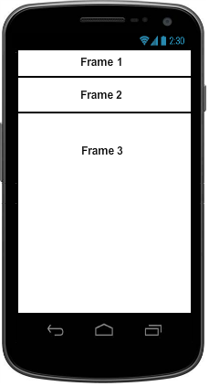

2.3 Generic Tables template

No tables are to be presented in the user interface.

2.4. Generic Forms Template

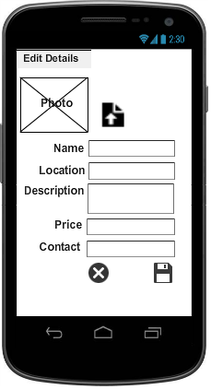

2.5. Narrative detailed specifications

2.5.1. Log In

|  |  |
| --- | --- |
| Screen  Name | MobiTel Log In |
| Background Colour | Grey (211,211,211) |
| Background Patterns | None |
| Background Pictures | None |
| Heading Font | Roboto Light |
| Heading Size | 13 |
| Heading Colour | Black |
| Heading Justification | Centered |
| Label Font | Roboto Regular |
| Label Size | 10 |
| Label Colour | Black |
| Label Justification | Right-aligned |
| Input Field Font | Roboto Regular |
| Input Field Size | 10 |
| Input Field Colour | Black |
| Input Field Justification | Left-aligned |
| General Font | Robot Regular |
| General Size | 10 |
| General Colour | Grey (211,211,211) |
| General Justification | Left-aligned |
| Motif/Logo | MobiTel logo |
| Sample |  |
| Special Notes | None |
| Navigation buttons | Log In– simple grey button. This button is pressed once the user has entered the correct username and password, and once the login details are verified, takes the user to the Business Details screen of the application. |
| Created by | Sinako Cetyiwe |
| Date Created | 13/08/2013 |

2.5.2. Manage Business/Accommodation/Room Details

|  |  |
| --- | --- |
| Form Name(s) | Edit/Add Business Details, Edit/Add Accommodation Details, and Edit/Add Room Details. |
| Background Colour | Grey (211,211,211) |
| Background Patterns | None |
| Background Pictures | None |
| Heading Font | Roboto Light |
| Heading Size | 13 |
| Heading Colour | Black |
| Heading Justification | Left-align |
| Label Font | Roboto Regular |
| Label Size | 10 |
| Label Colour | Black |
| Label Justification | Centre-align |
| General Font | Roboto Regular |
| General Size | 10 |
| General Colour | Black |
| General Justification | Left-aligned |
| Motif/Logo | None |
| Sample | None |
| Navigation buttons | Cancel– “X” icon that clears data on form and returns to previous screen.  Save – “Floppy disk” icon that saves data and returns user to the main class screen. E.g. Room/Business/Accommodation Screen | . |
| Special Notes | None |
| Created by | Sinako Cetyiwe |
| Date Created | 13/08/2013 |

2.6. Generic Reports

The developers recognize the need to have reports that would add value for the users of the application but this feature falls out of scope for the current project. The android application is built solely for the purpose of acting as a front-end for users to market their micro-tourism offerings on the Teleweaver micro-tourism portal/component. Bookings occur via telephonic communication between the prospective client and the business owner. For the sake of simplicity, payments will happen when the service is rendered. As informed by our needs analysis with representative users of the application, the users do not deem report generation as a need in completing their tasks – as many of them have very small operations (e.g. one or two homestay accomodation offerings) to an extent that merely using the application (viewing Business/Accomodation/Room screens) gives them an overview of their businesses and a reporting feature would add little, if any value. Given these considerations, the developers have decided to not have a reporting feature in the MobiTel application.

2.7. Interface Dependency Matrix

|  |  |  |  |  |  |  |  |
| --- | --- | --- | --- | --- | --- | --- | --- |
|  | **Use Cases for Iteration 2** | | | | | | |
| **Interface** | **Log In** | **Add Business** | **Manage Business details** | **Add Accommodation** | **Manage Accommodation details** | **Add Room** | **Manage Room details** |
| **Log in screen** | Profile |  |  |  |  |  |  |
| **Business Details Screen** |  | Business |  |  |  |  |  |
| **Edit Business details screen** |  |  | Business |  |  |  |  |
| **Accommodation Details** |  |  |  | Accommodation |  |  |  |
| **Edit Accommodation Details** |  |  |  |  | Accommodation |  |  |
| **Room Details** |  |  |  |  |  | Room |  |
| **Edit Room Details** |  |  |  |  |  |  | Room |
| **Photo Select Screen** |  | Business | Business | Accommodation | Accommodation | Room | Room |

2.8. Storyboard Navigation Diagram

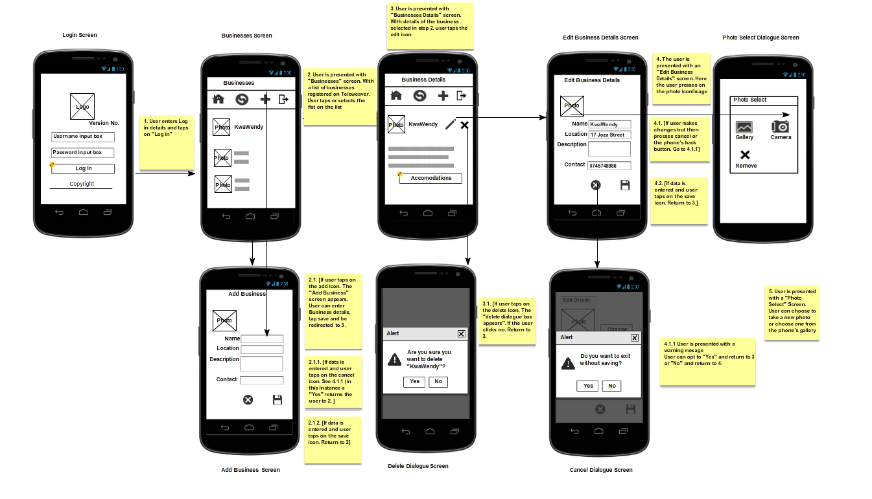2.8.1. Manage Business Details

2.8.2. Manage Accommodation Details

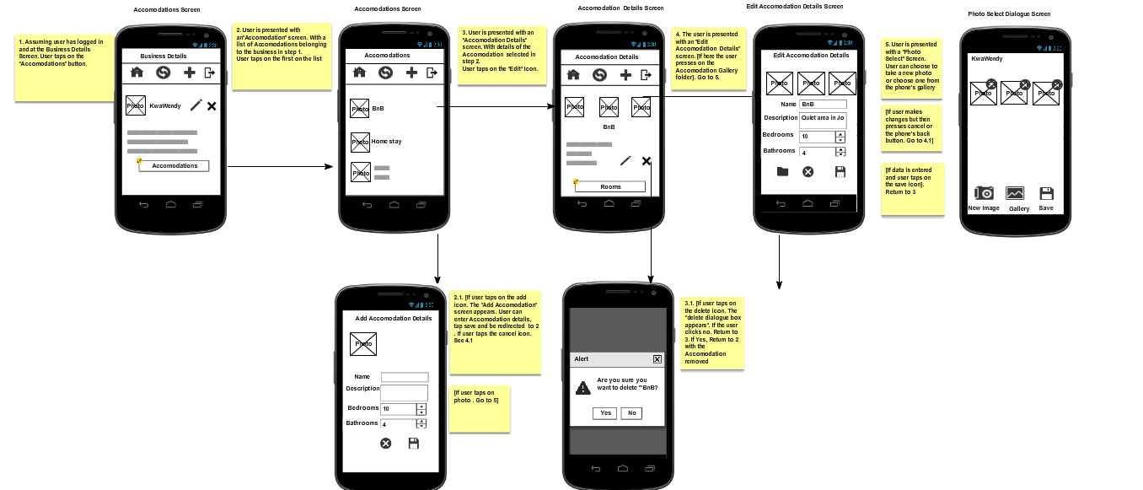

2.8.3. Manage Room Details

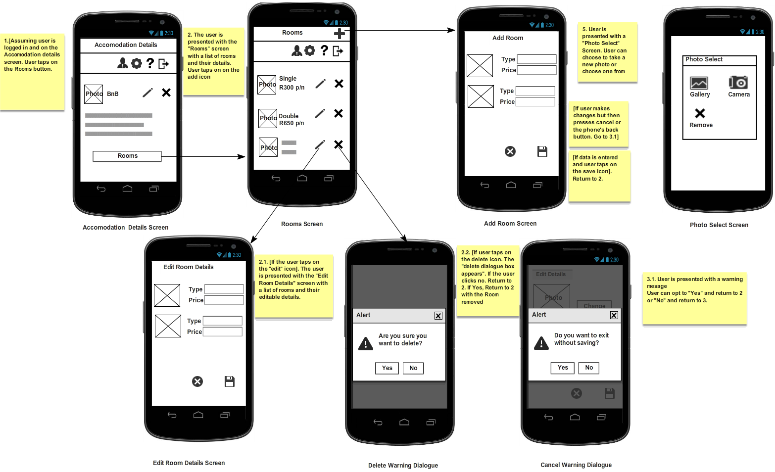

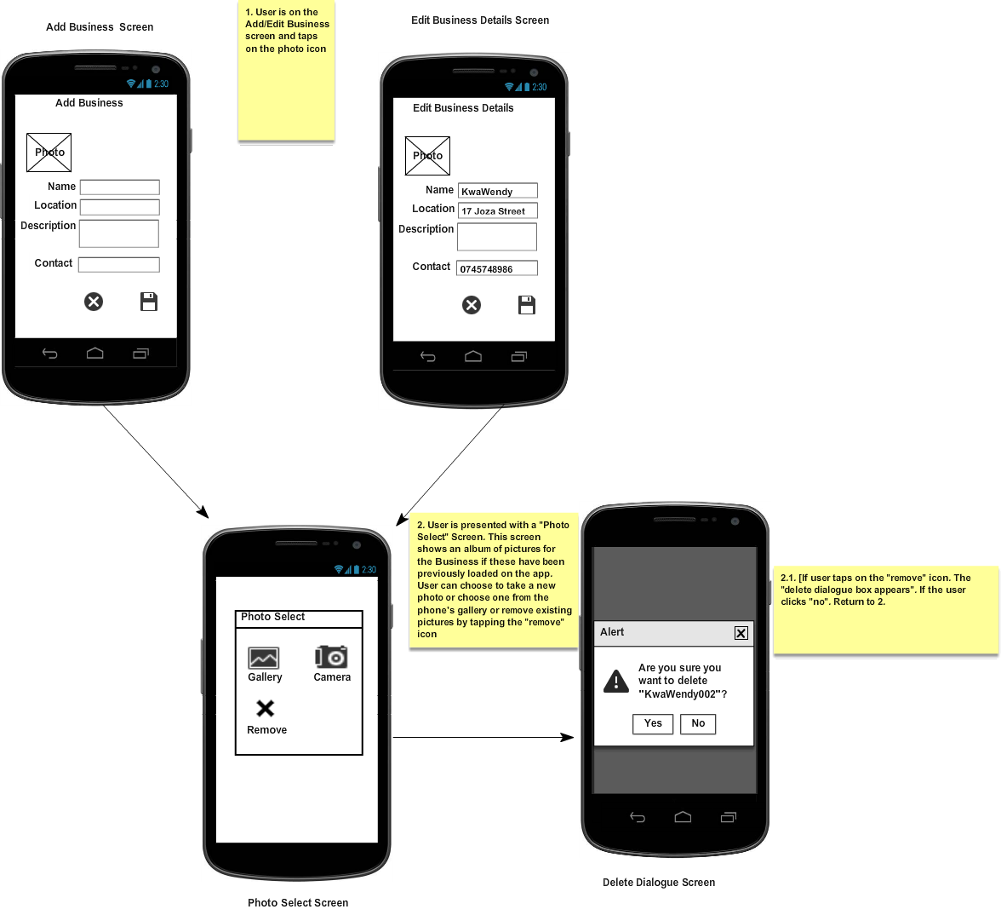2.8.4. Manage Business Photo

2.8.5. Manage Accommodation Photo

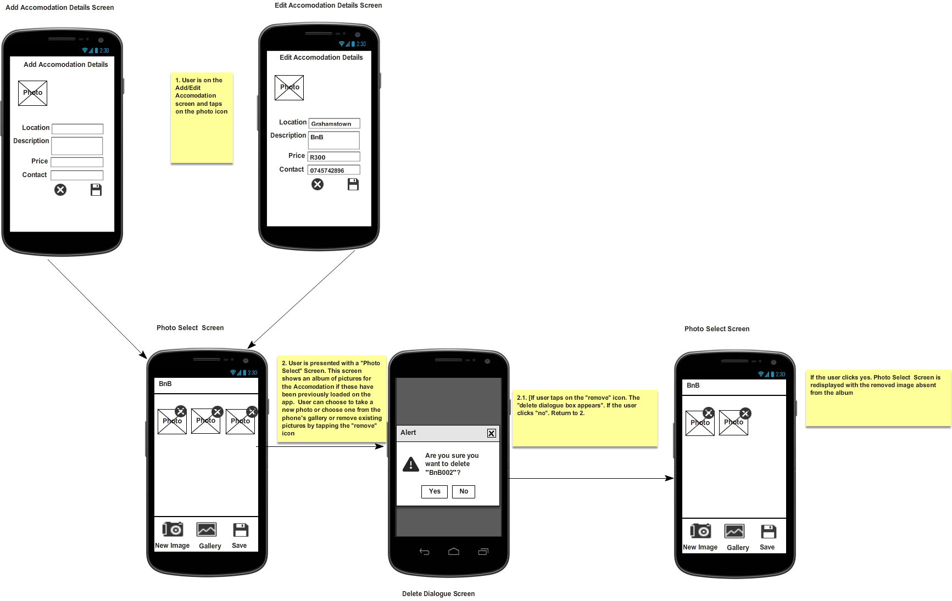

2.8.6. Manage Room Photo

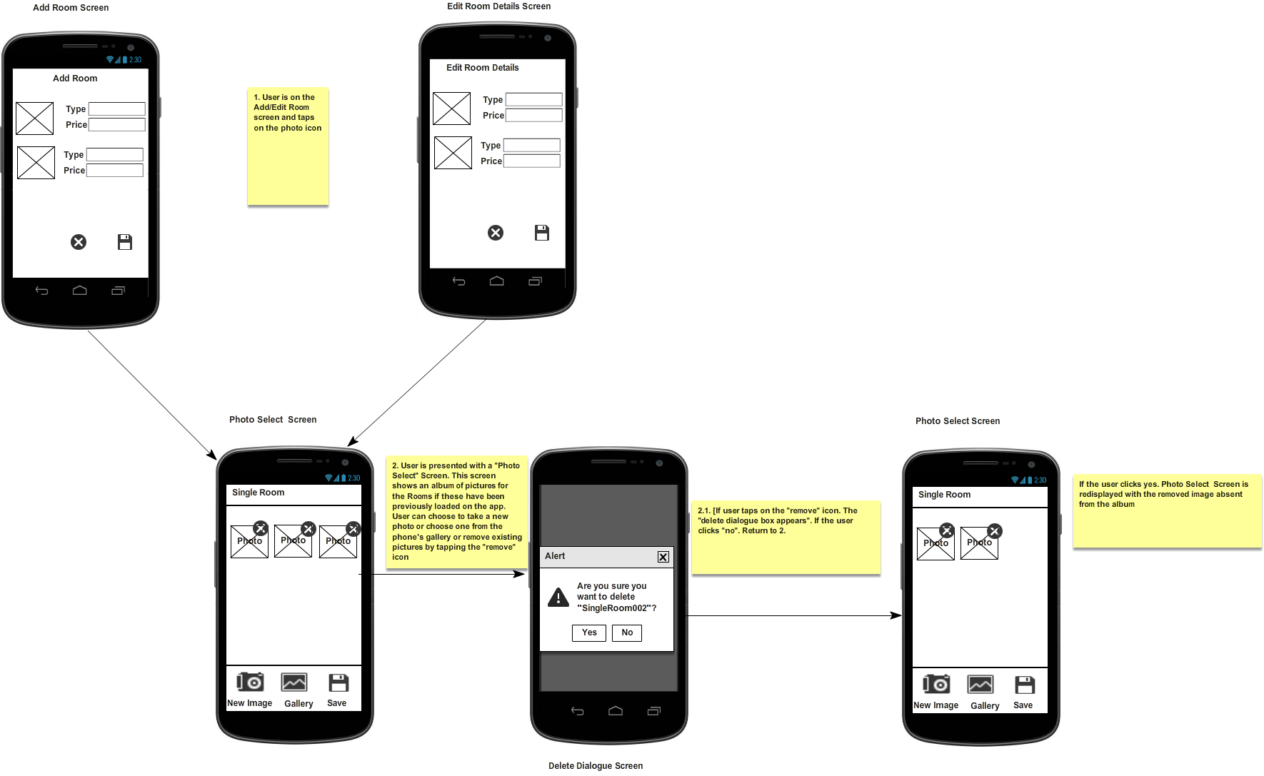

* + 1. 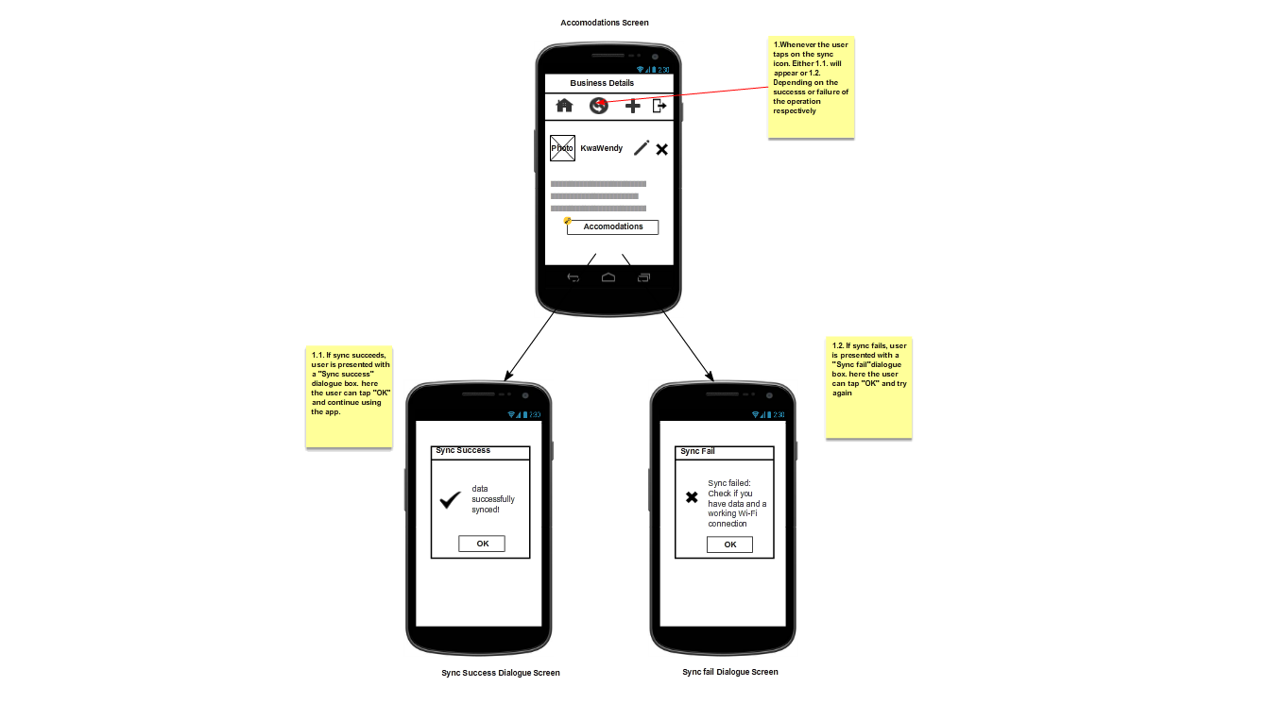Synchronise Data

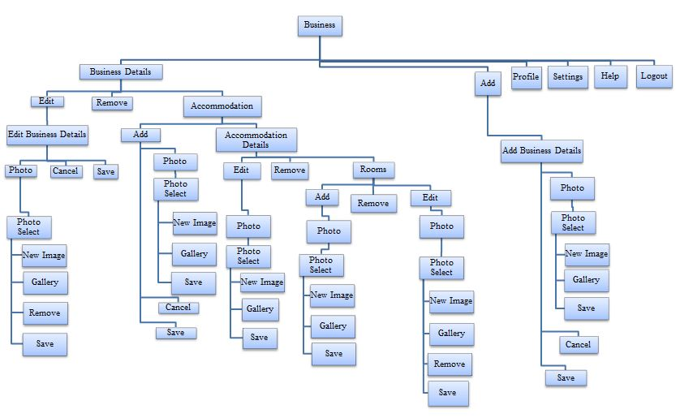2.9. Menu Hierarchy

**Figure 2.1 Menu Hierarchy Diagram**

2.10. Contextual Links

The MobiTel application will not use contextual links.

2.11. Testing & Usability

2.11.1. User Testing

The developers contacted representative users and arranged user testing sessions with them. Here users were put in a comfortable environment and given scenarios that require them to perform tasks on a high fidelity prototype of the application. The sessions had a facilitator who helped the users understand what is required of them. The users were given a briefing that was explained to them in their mother tongue (IsiXhosa) by the facilitator who then gave the users index cards with instructional scenarios for testing. The rest of the members of the development team took notes of the users’ actions to identify their pain points in using the application and other areas of improvements. See Appendix B for User Testing documentation.

|  |  |  |  |  |
| --- | --- | --- | --- | --- |
| **Item to Test**  **Testing Rubric** | **Test Description** | **Test Date** | **Responsibility** | **Comments** |
| Login | * Test Login Validations * Test logout | 10/08/2013 | Shana, Nonhlanhla | No Issues for this iteration. |
| Business Page | * Test all buttons * Test that edits save * Test validations * Test that only one image uploads * Test image upload from gallery and camera * Test removal of images * Test removal of business profiles | 10/08/2013 | Shana, Nonhlanhla | No Issues for this iteration. |
| Accommodation Page | * Test all buttons * Test that edits save * Test validations * Test that three images can upload * Test image upload from gallery and camera * Test removal of images * Test removal of accommodation profiles | 13/08/2013 | Ashley, Nicolan | No Issues for this iteration. |
| Room Page | * Test all buttons * Test that edits save * Test validations * Test that three images can upload * Test image upload from gallery and camera * Test removal of images * Test removal of room profiles | 14/08/2013 | SK, Lwando | No Issues for this iteration. |

1. Database Design

3.1. Internal Software Data Structure

MobiTel’s internal structure is split into two parts: a server-side and a client-side. On the client side, data will reside locally in the Android mobile device’s memory and will be organized based on the classes defined later in this section. Since the MobiTel program may be considered as data-centric, the classes that handle the data will be isolated and will be accessed by way of a Model-View-Controller system. The data on the local Android client will be requested from the server at application initialization and refreshed or synchronized as necessary based on user actions. The data structure on the server will be decided on by Reed House Systems, but the designers aim to design a local data structure that mirrors the data structure on the server side.

The server and Android client will exchange data using the JSON format. JSON is a lightweight object description language that is similar to XML. JSON was chosen over XML due to its versatility and because of the fact that an implementation is available for both PHP and JAVA.

3.1.1. Global Data Structure

The global data structure of this application is best characterized by the database. The database structure shows the data involved in the application in its purest sense. The local Android client of MobiTel will never access this database directly - it will instead issue requests to the server.

3.1.2 Relational Database Model Diagram (Temporary Data Structure)

The temporary data structure refers to the data objects that are created on the local Android client, and also to the JSON objects that interchanged between the server and the client. The JSON objects will only exist for the duration of the transaction between the client and server. The server will destroy the objects after sending them, and the client will destroy the JSON objects once they have been parsed.

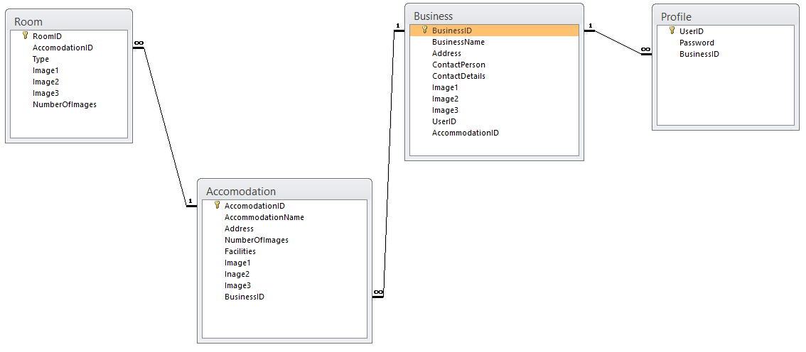

**Figure 3.1 Relationship Database Model Diagram**

3.2. Relationship Model

3.2.1 Table structure for table Accommodation

CREATE TABLE Accommodation (AccommodationID INTEGER PRIMARY KEY ASC, Name TEXT NOT NULL, Description TEXT NOT NULL, Price TEXT NOT NULL, Address TEXT NOT NULL, Type TEXT NOT NULL, Facilities TEXT NOT NULL, Image1 BLOB, Image2 BLOB, Image3 BLOB, NumberOfImages INTEGER NOT NULL, BusinessID INTEGER NOT NULL, FOREIGN KEY (BusinessID) REFERENCES Business(BusinessID))

3.2.2 Table structure for table Room

CREATE TABLE Room (RoomID INTEGER PRIMARY KEY ASC NOT NULL, AccommodationID INTEGER NOT NULL, Type TEXT NOT NULL, Image1 BLOB, Image2 BLOB, Image3 BLOB, NumberOfImages INTEGER NOT NULL , FOREIGN KEY (AccommodationID) REFERENCES Accommodation (AccommodationID))

3.2.3 Table structure for table Profile

CREATE TABLE Profile (UserID INTEGER PRIMARY KEY ASC NOT NULL, Password TEXT NOT NULL, BusinessID INTEGER NOT NULL, FOREIGN KEY (BusinessID) REFERENCES Business(BusinessID))

3.2.4 Table structure for table Business

CREATE TABLE Business (BusinessID INTEGER PRIMARY KEY ASC NOT NULL, BusinessType TEXT, BusinessName TEXT NOT NULL, Address TEXT NOT NULL, ContactPerson TEXT NOT NULL, ContactDetails TEXT NOT NULL, Image BLOB)

3.3 Database Size

|  |  |
| --- | --- |
| **Accommodation** | **Size** |
| AccommodationID | 5 |
| Description | 100 |
| Name | 20 |
| Address | 20 |
| Type | 15 |
| Facilities | 30 |
| Image1 | Object |
| Image2 | Object |
| Image3 | Object |
| NumberOfImages | 3 |
| BusinessID | 5 |
| **Total** | **198** |

|  |  |
| --- | --- |
| **Business** | **Size** |
| BusinessID | 5 |
| Name | 30 |
| Address | 30 |
| ContactPerson | 25 |
| ContactDetails | 10 |
| Image | Object |
| UserID | 5 |
| **Total** | **105** |

|  |  |
| --- | --- |
| **Room** | **Size** |
| RoomID | 5 |
| Type | 15 |
| Image1 | Object |
| Image2 | Object |
| Image3 | Object |
| NumberOfImages | 3 |
| AccomodationID | 5 |
| **Total** | **28** |
|  | |
| **Profile** | **Size** |
| UserID | 10 |
| Password | 10 |
| BusinessID | 5 |
| **Total** | **25** |

|  |  |  |  |  |  |  |
| --- | --- | --- | --- | --- | --- | --- |
| **Classes** | **Number of rows** | **Bytes** | **Bits** | **2 years** | **4 years** | **6 years** |
| Accommodation | 100 | 13400 | 107200 | 214400 | 428800 | 643200 |
| Room | 500 | 63500 | 508000 | 1016000 | 2032000 | 3048000 |
| Business | 50 | 14750 | 118000 | 236000 | 472000 | 708000 |
| Profile | 75 | 4500 | 36000 | 72000 | 144000 | 216000 |
| **Total** |  | **99750** | **798000** | **1596000** | **3192000** | **4788000** |

# 

1. System Control Design

4.1. Identified Threats

Viruses and malware present threats to the application as they can hinder the application from functioning properly or even functioning at all. Other threats include unauthorised users gaining access to the application thorough hacking, data loss or compromise, or erroneous user input. With these considerations the designers plan to design the system with security features and the developers will also make sure that the system has few if not any bugs that may compromise the system security. Validations will be used to prevent erroneous user input.

4.2. Audit Trails

Luminus Solutions understands the need for an audit trail to keep a record of the users’ interaction with the system. The audit trail should keep a log of what data was changed, when, and by whom (IP Address), and will show a timestamp of every change. Because of the limited memory and disk space on mobile devices, audit trails will be limited to only the most necessary cases such as unauthorised access attempts. No sensitive information will be logged.

There will be synchronisation between the mobile database logs and the server database logs to maintain audit capabilities on the server. As this is still early stages in development, this will be further explored and more detail will be included in the forthcoming iterations.

4.3. System Access and Control

The system can only be accessed by users who have been registered on Teleweaver. The users will be issued with a password and username which will be used to log onto the system. These users have access to all functions of the application. This system control prevents unauthorised users from accessing the system. The business owner who is the only who ideally has access to the application and hence there is only one level of access. This also means that the Business Owner has access to all the functionality of the application.

4.4. Backup and Recovery Facilities

Teleweaver will be facilitating the necessary backup and recovery facilities.

1. Architectural Design

5.1. Architectural layer design

The application is divided into two major components: a client-side Android application and a server-side PHP application and MySQL database. Our project scope is only within the client-side Android application which is also separated into two parts: the process component (written in Basic) using Basic4Android as the IDE, and the graphical UI component. The process component receives user input and constructs objects such as 'business' and 'accommodation'. The graphical UI component is the graphical user interface that the end-user interacts with, it contains the icons, pictures, buttons, text boxes, and other onscreen elements which allow the user to interact with the application and access the features of the application. The server component of the application manages incoming and outgoing messages and an SQL database, which provides centralized storage for synchronized data. The server application receives serialized data from the Android application and parses it into useful information. This data is then stored in the database.

5.1.1. System architecture

A description of the system architecture is illustrated in ﬁgure 5.1.1. From the left-hand side an Android device (smartphone or even a tablet) with the MobiTel application already installed communicates with the Teleweaver web service using a custom RESTful API. The application sends HTTP requests with GET/PUT/POST/DELETE method headers and receives well formatted JSON responses. REST objects can be exchanged both ways.

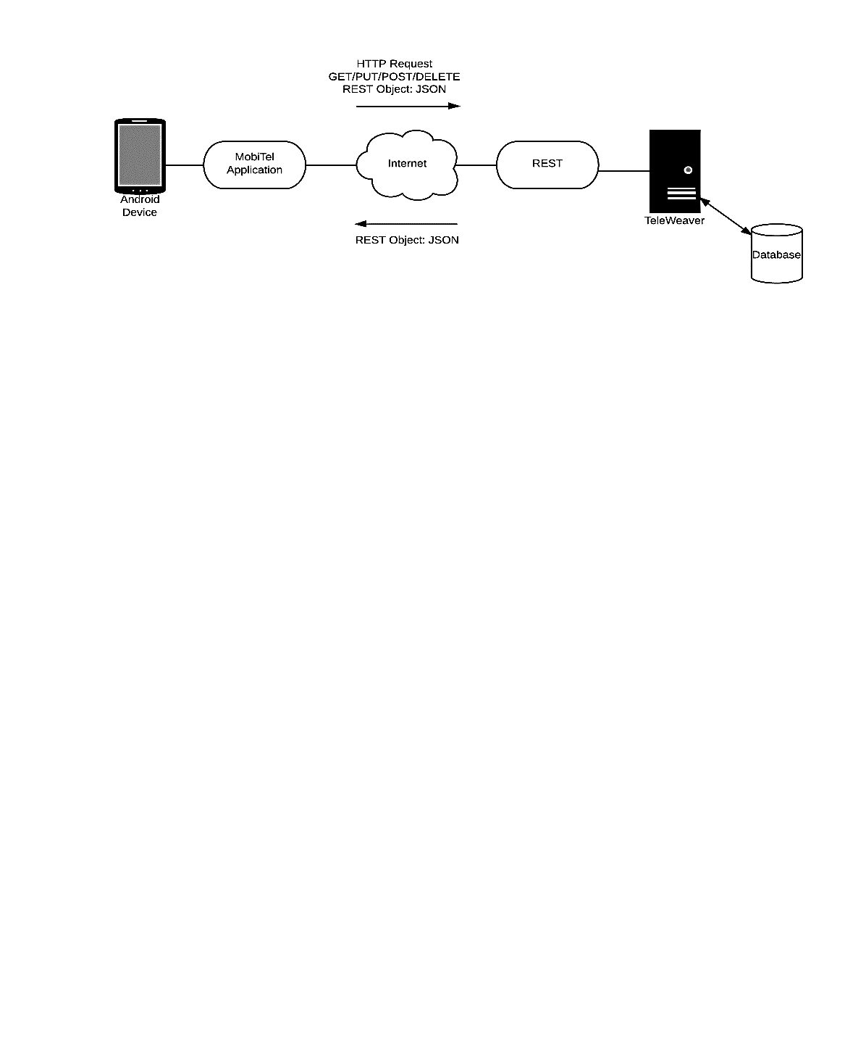

**Figure 5.1.1. System Architectural layer design**

5.1.2. Application’s architecture

This architectural perspective presents the MobiTel application in isolation. The entire application is built up as a module. This module has contains quite loosely connected components, but the one thing they all have in common is that they all use Android libraries, so they can only be used on Android devices.

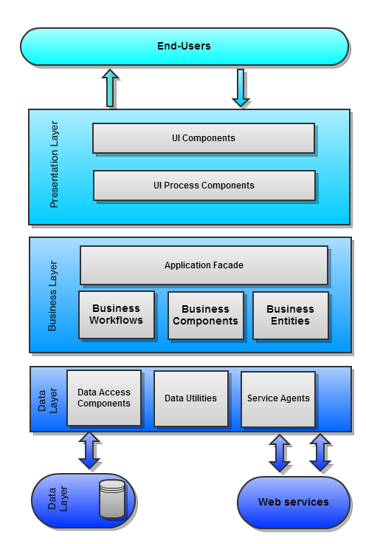

**Figure 5.1.2 Application Architectural layer design**

5.1.3 Software and Hardware Platforms

|  |  |  |
| --- | --- | --- |
| **Components** | **Minimum Requirements** | **Recommended Requirements** |
| **Operating System** | Android 2.3–2.3.2 Gingerbread (API level 9) | Android 4.2 Jelly Bean (API level 17) |
| **Processor** | 1GHz ARM based chipset | 1.5 GHz quad-core processor |
| **Memory** | 256 MB RAM | 512 MB RAM |
| **Hard Drive** | 400MB of Free Space | 400MB of Free Space |
| **Display** | 3.2 inches (81 mm) 800x480 WVGA;  16-bit colour | 4.7 in (120 mm); 1280×768 px |
| **Bluetooth** | Bluetooth 2.0 | Bluetooth 3.0 |
| **Internet Connectivity** | EDGE, 3G | Wi-Fi 802.11 |
| **Camera** | 2MP CMOS | 5MP CMOS |

5.1.4. Operating System Software requirements:

The operating system of choice is Android Gingerbread. Android has the largest worldwide smartphone market share (75% in the third quarter of 2012). Gingerbread was chosen as the minimum because it is the most widely distributed version of Android (38.4% in March 2013). Android is also open-source therefore there is no risk of vendor “lock-in”. No vendor can restrict its development. Android also has a large community of developers who continuously improve it with revolutionary technologies. Android software is written in Java, a well-supported language with thousands of modules, extensions and reference documentation.

5.1.5. Application Software requirements

The mobile devices used by the users should be compatible with and run Android 2.3–2.3.2 Gingerbread (API level 9) or later.

5.2 Network requirements

5.2.1. Network Software

The application will make use of Representational State Transfer (REST). This is a predominant [web API](https://en.wikipedia.org/wiki/Web_API) design model for distributed systems.

5.2.2. Network Hardware

Wi-Fi 802.11 adapter, Bluetooth 2.0 port or later.

#### 5.2.3 Network Topology

The developers have chosen a switched point-to-point network topology.

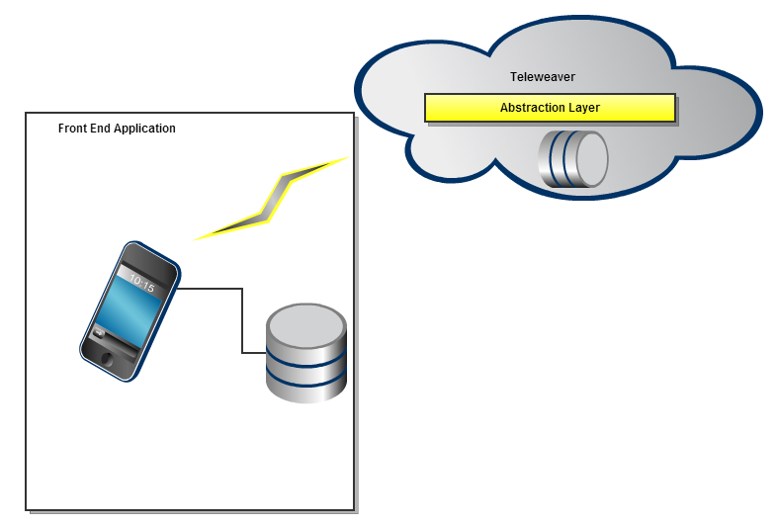

**Figure 5.2. Network Topology**

5.3 Help

5.3.1 Help Description

Help facilities will be provided on the application to allow for simple navigation through the help facility by using search functions as well as various links. As further forms of help, validation checks have been included in the application to guide users should they fail to enter correct data. All features of the help facility will also be available to the users in the form of a hard copy help manual which will be distributed during the deployment of the application. This is to allow users to still have access to help should the systems help function malfunction.

5.3.2 Help Tree

1. General
   1. Welcome
   2. Help Desk
   3. Getting Started
   4. Navigation
2. Login Information
   1. Logging in
   2. Changing Password
3. Managing Businesses
   1. Add Business
   2. Edit Business
   3. Remove Business
4. Business Page
   1. Add Business
   2. Edit Business Details
   3. Remove Business
   4. Add Business Image
5. Accommodation Page
   1. Add Accommodation
   2. Edit Accommodation Details
   3. Remove Accommodation
   4. Add Accommodation Images
6. Room Page
   1. Add Room
   2. Edit Room Details
   3. Remove Room
   4. Add Room Images
7. Sync To TeleWeaver

5.4 Frequently Asked Questions

The application will make use of the FAQ’s. These FAQ’s will be split into sections and represented as follows:

* **Business**

**How do I add a business?**

You can add a new business by selecting the add button which is located on the top of the screen. The ‘Add Business’ screen will then appear: You can then enter your business information in the relevant fields

**How do I edit my business details?**

You can edit your business details by selecting the ‘Edit’ icon on the ‘Business Details’ screen. The ‘Edit Business Details’ screen will then be displayed. Once you have edited your business details you can then select the ‘Save’ icon to save the changes.

**How do I add images to the Business Profile**?

You are only permitted to upload one image per business. You can add an image by selecting the camera icon. You can choose to upload an image from your gallery or by taking a photo using your mobile device. Once you have entered all your business information, select on the ‘Save’ icon.

**How do I remove a business?**

To remove a business from the app, select the business you want to remove on the ‘Businesses’ screen. The ‘Business Details’ screen will then appear. Select the ‘Remove’ icon. An alert will appear requesting you confirm whether you are sure you want to remove the business profile you have selected. To confirm that you want to remove the selected business, select ‘Yes’. If you do not want to remove the selected business, select ‘No’. Once you have selected ‘Yes’ to confirm that you want to remove the business, the ‘Businesses’ screen will appear with the removed business not visible on the screen

* **Accommodation**

**How do I add an accommodation?**

You can add a new accommodation by selecting the ‘Add’ icon, which is located on the top of the screen. The ‘Add Accommodation’ screen will then appear. Enter your accommodation information in the relevant fields.

**How do I edit my accommodation details?**

You can edit your accommodation details by selecting the ‘Edit’ icon on the ‘Accommodation Details’ screen. The ‘Edit Accommodation Details’ screen will then be displayed. Once you have edited your accommodation details you can then select the ‘Save’ icon to save the changes.

**How do I add images to the Business Profile**?

You are only permitted to upload 3 images per business. You can add an image by selecting the ‘Accommodation Gallery’ icon. An ‘Accommodation Gallery’ dialog box will appear. You can choose to upload an image from your gallery by selecting the gallery icon or by taking a photo using your mobile device. To do this you would select the ‘New Image’ icon. Once you have entered the images, select the ‘Save’ icon.

**How do I remove an accommodation?**

To remove an accomodation from the app, select the accommodation you want to remove on the ‘Accommodations’ screen. The ‘Accommodation Details’ screen will then appear. Select the ‘Remove’ icon . An alert will appear requesting you to confirm whether you are sure that you want to remove the accommodation profile you have previously selected. To confirm that you want to remove the selected accommodation, select ‘Yes’. If you do not want to remove the selected accommodation, select ‘No’.

* **Room**

**How do I add a room?**

You can add a new room by selecting the ‘Add’ icon, which is located on the top of the screen. The ‘Add Room’ screen will then appear. Enter your room information in the relevant fields.

**How do I edit my room details?**

You can edit your room details by selecting the ‘Edit’ icon on the ‘Rooms’ screen. The ‘Edit Room’ screen will then be displayed. Once you have edited your room details you can then select the ‘Save’ icon to save the changes.

**How do I add images to the room profile?**

You can add an image by selecting the ‘Camera’ icon. A ‘Room Image’ dialog will appear. You can choose to upload an image from your gallery or by taking a photo using your mobile device. Once you have entered the images, select the ‘Save’ icon.

**How do I remove a room?**

To remove a room from the app, select the room you want to remove on the ‘Rooms’ screen. The ‘Accommodation Details’ screen will then appear. When you select the ‘Remove’ icon, an alert will appear requesting you to confirm whether you are sure you want to remove the accommodation profile you have selected. To confirm that you want to want to remove the selected room, select ‘Yes’. If you do not want to remove the selected room, select ‘No’.

* **Access**

**How do I log in?**

Enter your username and password for Teleweaver (as assigned to you by Reed House Systems) and select Login.

**How do I log out?**

To exit the application, select on the ‘Logout’ icon. This icon is present at the top-right corner of every screen.

**How do I change my password?**

To change your password you would need log onto the Teleweaver Website and make the changes from there. Password changes cannot be made on the application.

* **Miscellaneous**

**What is Mobitel?**

Mobitel is a simple mobile applications that allows business owners with accommodation services such as Lodges, BnB’s and Homestays to publish information and pictures onto a website.

**How much does it cost?**

There is no cost, the app is absolutely free.

**If I have a technical issue, who do I contact?**

If you have any technical issue with the app, please contact the Reed House Systems Administrator via email.

**How do I change the language?**

You can change the language on the Login Screen by selecting the language a drop down menu will appear. The app is currently only available in English and Xhosa.

**How do I synchronize my details on the app?**

To synchronise, you must be connected to a designated Wi-Fi network. To synchronise your information, select the ‘Sync’ icon, which can be found at the top of all the main screens on the app. Once you select the ‘Sync’ icon, a dialog box will appear to alert you that all your information has been synchronised. If you have already synchronised and there is no new information to synchronise on the app, a dialog will appear informing you.

**Can I use the app on other platforms like Blackberry and Apple?**

Currently the application is specifically developed for Android users so unfortunately it will not work on other platforms.

1. Function and Program Design

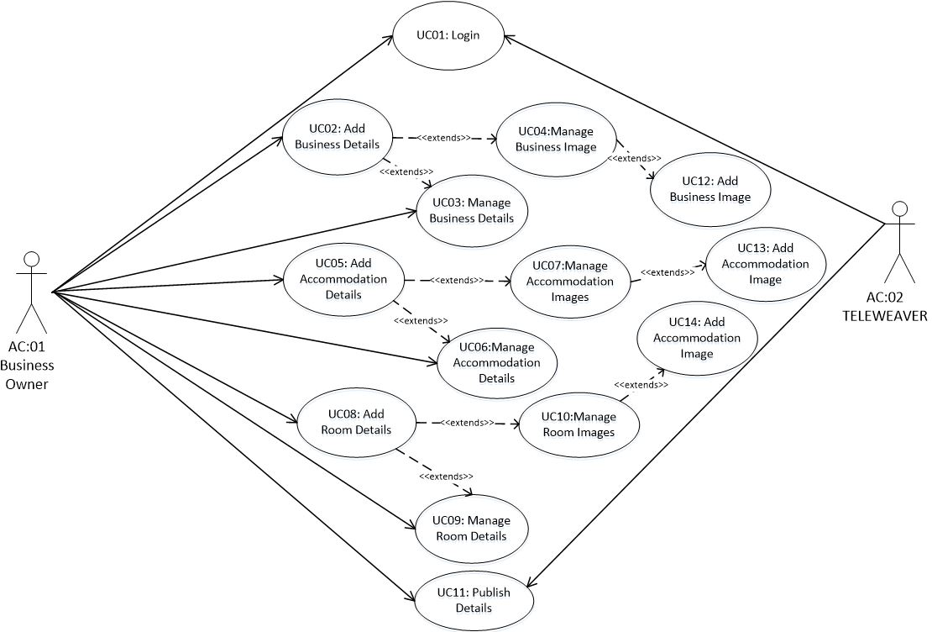6.1. Design-level Use Case diagram

6.2. Design Use Case Narratives and User Interface Screen Mock ups

6.2.1. Login

|  |  |
| --- | --- |
| Use Case # | **UC01** |
| Use Case | **Login** |
| Purpose: | This use case serves the purpose of granting the Business Owner access to create, update, and delete data on the mobile application relating to their business |
| Overview: | This use case details the login steps of the Business Owner |
| Actors: | Business Owner |
| Type: | Essential |
| Preconditions | The Business Owner has already registered on Teleweaver and has a username and password. |
| Postconditions: | The Business Owner object is available to other use cases. |
| Special Requirements: | None |
| **Main Flow of Events** | |
| **ACTION** | **SYSTEM RESPONSE** |
| 1. This use case begins when the User opens the application by tapping on the application logo on their mobile device’s menu screen  3. Business Owner enters the username and password by tapping on the fields and entering the credentials.  4. Business Owner presses the LOGIN button. | 2. The login screen displays with two input boxes (username and password) and a LOGIN button.    5. The system locates the Business Owner object  6. The system verifies the Business Owner’s login details for access rights  7. The system displays the Business screen with an overview of the Business Owner’s list of businesses. |
| **Alternative Flow of Events** | |
| Line 5: If the Business Owner object cannot be found  Line 6: If the Business Owner enters unverifiable login details | System displays the “Username and password incorrect, try again” message and terminates the use case.  System displays “Username and password incorrect, try again” message and terminates the use case. |
| Activity Diagrams: | None |
| System Operations: | * Enter Username and Password (username, password) |
| Author: | Sinako Cetyiwe |
| Date created: | 14/05/2013 |
| Date modified: | 02/09/2013 |
| User Interface Screen Mock-up |  |
| Modified by: | Lwando Sobekwa |

6.2.2. Manage Business Details

|  |  |
| --- | --- |
| Use Case # | **UC03** |
| Use Case: | **Manage Business Details** |
| Purpose: | This use case is for the purpose of editing and removing business details. |
| Overview: | This use case details the steps the Business Owner takes when they want to modify business details. |
| Actors: | Business Owner |
| Type: | Essential |
| Preconditions | The Business Owner has logged on to the application. The business already exists in the system. |
| Postconditions: | The correct business details are now stored, available for viewing on the application and ready to sync with Teleweaver. |
| Special Requirements: | None |
| **Main Flow of Events** | |
| **ACTION** | **SYSTEM RESPONSE** |
| 1. This use case begins when the Business Owner decides to edit information about their business.  2. On the Business screen the Business Owner selects the Business from the list by tapping on the business whose details they want to view.  4. The Business Owner selects the Edit icon.  6. The Business Owner edits the business details by tapping on the field they wish to edit and modifies the details.  7. When completed, the Business Owner selects the Save icon. If the Cancel icon is selected instead, the alternative flow of the event occurs.  9. Repeat steps 4 to 7 for every business whose details need to be updated. | 3. A Business Details screen displays which has the business details (name, type, contact number, address, contact person etc.) containing an add, edit and remove icon.  5. An Edit Business Details screen is displayed with editable fields (name, type, contact number, address, and contact person).  8. The updated business details are saved and the Business screen is redisplayed. |
| **Alternative Flow of Events** | |
| Line 7: The Business Owner selects the Cancel icon.  Line 4: The Business Owner selects the remove icon | A message box appears asking the Business Owner “Are you sure you want to return without saving?” If the “No” button is selected, the Edit Business Details screen is redisplayed. If the “Yes” button is selected, the changes are cancelled and the Business screen is displayed.  A message box appears asking the Business Owner “Are you sure you want to delete [Business name]”. If the “No” button is selected, the Business Details screen is redisplayed. If the “Yes” button is selected, the business is removed from the application’s database [and business list] and the Business screen is displayed. |
| Activity Diagrams: | None referred to |
| System Operations: | * editBusinessDetails(name, type, contact number, address, contact person) * removeBusinessDetails(name, type, contact number, address, contact person) |
| Author: | Lwando Sobekwa |
| Date created: | 16/05/2013 |
| Date modified: | 05/09/2013 |
| Modified by: | Lwando Sobekwa |

6.2.3 Add Business Details

|  |  |
| --- | --- |
| Use Case # | **UC03** |
| Use Case: | **Add Business Details** |
| Purpose: | This use case is for the purpose of adding business details. |
| Overview: | This use case details the steps the Business Owner takes when they want to add new business details. |
| Actors: | Business Owner |
| Type: | Essential |
| Preconditions | The Business Owner has logged on to the application. |
| Postconditions: | The new business details are now stored, available for viewing on the application and ready to sync with Teleweaver. |
| Special Requirements: | None |
| **Main Flow of Events** | |
| **ACTION** | **SYSTEM RESPONSE** |
| 1. This use case begins when the Business Owner decides to add new business details.  2. On the Business screen the Business Owner selects the add icon at the top right of the screen by tapping it.  4. The Business Owner adds the business details by tapping on the field they wish to enter.  5. When completed, the Business Owner selects the Save icon. If the Cancel icon is selected instead, the alternative flow of the event occurs.  7. Repeat steps 2 to 5 for every business whose details need to be updated. | 3. An Add Business Details screen displays which empty fields (name, type, contact number, address, contact person etc.) containing a save and cancel icons.  6. The new business details are saved and the Business screen is displayed. |
| **Alternative Flow of Events** | |
| Line 5: The Business Owner selects the Cancel icon. | A message box appears asking the Business Owner “Are you sure you want to return without saving?” If the “No” button is selected, the Add Business Details screen is redisplayed. If the “Yes” button is selected, the changes are cancelled and the Business screen is displayed. |
| Activity Diagrams: | None referred to |
| System Operations: | * addBusinessDetails(name, type, contact number, address, contact person) |
| Author: | Lwando Sobekwa |
| Date created: | 16/05/2013 |
| Date modified: | 05/09/2013 |
| Modified by: | Lwando Sobekwa |

6.2.4 Manage Accommodation Details

|  |  |
| --- | --- |
| Use Case # | **UC06** |
| Use Case: | **Manage Accommodation Details** |
| Purpose: | This use case is for the purpose of editing and removing accommodation details. |
| Overview: | This use case details the steps the Business Owner takes when they want to edit accommodation details. |
| Actors: | Business Owner |
| Type: | Essential |
| Preconditions | An accommodation already exists in the system. |
| Postconditions: | The correct accommodation details are now stored, available for viewing on the application and ready to sync with Teleweaver. |
| Special Requirements: | None |
| **Main Flow of Events** | |
| **ACTION** | **SYSTEM RESPONSE** |
| 1. This use case begins when the Business Owner decides to edit information about their accommodation(s).  2. On the Business screen the Business Owner selects the Business from the list by on the business whose details they want to view.  4. The Business Owner selects the Accommodation Details button on the bottom of the screen by tapping it.  6. The Business Owner selects an accommodation from the list of accommodations by tapping on the given accommodation.  8. The Business Owner selects the edit icon at the top of the screen  10. The Business Owner edits the accommodation details by tapping on the fields they wish to edit.  11. When completed, the Business Owner selects the Save icon. If the Cancel icon is selected instead, the alternative flow of the event occurs.  13. Repeat steps 8 to 11 for every business whose details need to be updated. | 3. A Business Details screen displays which has the business details (name, address, contact person etc.) containing an add, edit and remove icon.  5. The Accommodations screen is displayed, with the list of the accommodations the Business Owner has.  7. An Accommodation Details screen is displayed, with accommodation description, location, type etc.  9. An Edit Accommodation Details screen is displayed with editable fields (Type, location, description, price and contact), a save and cancel button.  12. The updated accommodation details are saved and the Accommodation(s) screen is redisplayed. |
| **Alternative Flow of Events** | |
| Line 7: The Business Owner selects the Cancel icon. | A message box appears asking the Business Owner “Are you sure you want to return without saving?” If the No button is selected, the Edit Accommodation Details screen is redisplayed. If the Yes button is selected, the changes are cancelled and the Accommodations screen is displayed. |
| Activity Diagrams: | None referred to |
| System Operations: | * editAccommodationDetails(Type, location, description, price and contact) * removeAccommodationDetails(Type, location, description, price and contact) |
| Author: | Lwando Sobekwa |
| Date created: | 16/05/2013 |
| Date modified: | 05/09/2013 |
| User Interface Screen Mock-up | C:\Users\g09s2467\Dropbox\Honours SysDev\Luminus Solutions Iteration 3\Design\Screenshots\accommodationDetails (Lwando Sobekwa's conflicted copy 2013-09-09).PNG |
| Modified by: | Lwando Sobekwa |

6.2.5 Add Accommodation Details

|  |  |
| --- | --- |
| Use Case # | **UC05** |
| Use Case: | **Add Accommodation Details** |
| Purpose: | This use case is for the purpose of adding new accommodation details. |
| Overview: | This use case details the steps the Business Owner takes when they want to add new accommodation details. |
| Actors: | Business Owner |
| Type: | Essential |
| Preconditions | The Business Owner has logged on to the application. |
| Postconditions: | The accommodation details are now stored, available for viewing on the application and ready to sync with Teleweaver. |
| Special Requirements: | None |
| **Main Flow of Events** | |
| **ACTION** | **SYSTEM RESPONSE** |
| 1. This use case begins when the Business Owner decides to add new accommodation information.  2. On the Business screen the Business Owner selects the Business from the list by.  4. The Business Owner selects the Accommodation Details button on the bottom of the screen by tapping it.  6. The Business Owner selects the Add icon at the top right of the screen by tapping it.  8. The Business Owner enters the new accommodation details by tapping on the fields provided ant entering the details.  9. When completed, the Business Owner selects the Save icon. If the Cancel icon is selected instead, the alternative flow of the event occurs.  11. Repeat steps 6 to 9 for every new accommodation whose details need to be added. | 3. A Business Details screen displays which has the business details (name, address, contact person etc.) containing an add, edit and remove icon.  5. The Accommodations screen is displayed, with the list of the accommodations the Business Owner has and an Add icon at the top right of the screen.  7. An Add Accommodation Details is displayed with empty fields where the Business Owner inputs the details (Type, location, description, price and contact), with a save and cancel icon.  10. The new accommodation details are saved and the Accommodation(s) screen is displayed. |
| **Alternative Flow of Events** | |
| Line 9: The Business Owner selects the Cancel icon. | A message box appears asking the Business Owner “Are you sure you want to return without saving?” If the No button is selected, the Add Accommodation Details screen is redisplayed. If the Yes button is selected, the changes are cancelled and the Accommodations screen is displayed. |
| Activity Diagrams: | None referred to |
| System Operations: | * addAccommodationDetails(Type, location, description, price and contact) |
| Author: | Lwando Sobekwa |
| Date created: | 16/05/2013 |
| Date modified: | 27/10/2013 |
| User Interface Screen Mock-Up: | C:\Users\LoneWolf\Dropbox\Honours SysDev\Translations\addAccommodation.PNG |
| Modified by: | Sinako Cetyiwe; Lwando Sobekwa |

6.2.6 Manage Room Details

|  |  |
| --- | --- |
| Use Case # | **UC09** |
| Use Case: | **Manage Room Details** |
| Purpose: | This use case is for the purpose of editing or removing room details. |
| Overview: | This use case details the steps the Business Owner takes when they want to edit or remove room details. |
| Actors: | Business Owner |
| Type: | Essential |
| Preconditions | A room already exists in the application. |
| Postconditions: | The correct room details are now stored, available for viewing on the application and ready to sync with Teleweaver. |
| Special Requirements: | None |
| **Main Flow of Events** | |
| **ACTION** | **SYSTEM RESPONSE** |
| 1. This use case begins when the Business Owner selects the Accommodations button [by tapping it] on the button of the screen on the Business Details screen.  3. The Business Owner selects the Room details button by tapping it.  5. The Business Owner selects the edit icon by tapping it.    7. The Business Owner edits the accommodation details by tapping on the field they wish to edit.  8. When completed, the Business Owner selects the Save icon. If the Cancel icon is selected instead, the alternative flow of the event occurs.  13. Repeat steps 5 to 8 for every business whose details need to be updated. | 2. The Accommodations screen is displayed, with the list of the accommodations the Business Owner has, plus a remove and edit icons and a Room details button at the bottom of the screen.  4. A Rooms screen is displayed with the room details (type and price) plus an add, edit and remove icons.  6. An Edit room details screen is displayed with editable fields (type and price), plus a save and cancel button.  9. The updated room details are saved and the Rooms screen is displayed. |
| **Alternative Flow of Events** | |
| Line 7: The Business Owner selects the Cancel icon.  Line 5: The Business Owner selects the remove icon | A message box appears asking the Business Owner “Are you sure you want to return without saving?” If the “No” button is selected, the Edit Room Details screen is redisplayed. If the “Yes” button is selected, the changes are cancelled and the Rooms screen is displayed.  A message box appears asking the Business Owner “Are you sure you want to delete”. If the “No” button is selected, the Rooms screen is redisplayed. If the “Yes” button is selected the room details are removed from the application’s database and the Rooms screen is redisplayed. |
| Activity Diagrams: | None referred to |
| System Operations: | * editRoomDetails(type, price) * removeRoomDetails(type, price) |
| Author: | Lwando Sobekwa |
| Date created: | 16/05/2013 |
| Date modified: | 27/10/2013 |
| User Interface Screen Mock-up | C:\Users\LoneWolf\Dropbox\Honours SysDev\Translations\editRoom.PNG |
| Modified by: | Lwando Sobekwa; Sinako Cetyiwe |

6.2.7 Add Room Details

|  |  |
| --- | --- |
| Use Case # | **UC08** |
| Use Case: | **Add Room** |
| Purpose: | This use case is for the purpose of adding new room details. |
| Overview: | This use case details the steps the Business Owner takes when they want to add new room details. |
| Actors: | Business Owner |
| Type: | Essential |
| Preconditions | The Business Owner has logged on to the application. |
| Postconditions: | The correct room details are now stored, available for viewing on the application and ready to sync with Teleweaver. |
| Special Requirements: | None |
| **Main Flow of Events** | |  |
| **ACTION** |  |
| 1. This use case begins when the Business Owner selects the Accommodations button [by tapping it] on the button of the screen on the Business Details screen.  3. The Business Owner selects the Room details button by tapping it.  5. The Business Owner selects the Add icon by tapping it.  7. The Business Owner enters the new room details by tapping on the fields and entering the details.  8. When completed, the Business Owner selects the Save icon. If the Cancel icon is selected instead, the alternative flow of the event occurs.  11. Repeat steps 5 to 8 for every new room whose details need to be added. | 2. The Accommodations screen is displayed, with the list of the accommodations the Business Owner has, plus a remove and edit icons and a Room details button at the bottom of the screen.  4. A Rooms screen is displayed with the room details (type and price) plus an add, edit and remove icons.  6. An Add Room Details screen is displayed, with empty fields (type, price)  10. The new room details are saved and the Rooms screen is displayed. |
| **Alternative Flow of Events** | |  |
| Line 9: The Business Owner selects the Cancel icon. | A message box appears asking the Business Owner “Are you sure you want to return without saving?” If the No button is selected, the Add Room Details screen is redisplayed. If the Yes button is selected, the changes are cancelled and the Rooms screen is displayed. |
| Activity Diagrams: | None referred to |
| System Operations: | addRoomDetails(type, price) |
| Author: | Lwando Sobekwa |
| Date created: | 16/05/2013 |
| Date modified: | 27/10/2013 |
|  | C:\Users\LoneWolf\Dropbox\Honours SysDev\Translations\addRoom.PNG |
| Modified by: | Lwando Sobekwa |

6.2.8 Manage Business Image

|  |  |
| --- | --- |
| Use Case # | **UC04** |
| Use Case: | **Manage Business Image** |
| Purpose: | This use case is for the purpose of editing and removing a business image. |
| Overview: | This use case details the steps the Business Owner takes when they want to modify their business image. |
| Actors: | Business Owner |
| Type: | Essential |
| Preconditions | The business already exists in the system. |
| Postconditions: | The correct business image is now uploaded, available for viewing on the application and ready to sync with Teleweaver. |
| Special Requirements: | None |
| **Main Flow of Events** | |
| **ACTION** | **SYSTEM RESPONSE** |
| 1. This use case begins when the Business Owner decides to modify their business image.  2. On the Business screen the Business Owner selects the Business from the list by tapping on the business whose details they want to view.  4. The Business Owner selects the Edit icon by tapping it.  6. To add an image the Business Owner selects the photo icon by tapping it.  8. The Business Owner selects the Gallery icon.  10. The Business Owner selects the image by tapping it.  12. When completed, the Business Owner selects the Save icon. If the Cancel icon is selected instead, the alternative flow of the event occurs.  13. Repeat steps 6 to 12 for every business whose details need to be updated. | 3. A Business Details screen displays which has the business details (name, type, contact number, address, contact person etc.) containing an add, edit and remove icon.  5. An Edit Business details screen is displayed with empty fields (details (name, type, contact number, address and contact person) and a photo icon on the top left of the screen.  7. A photo select pop-up is displayed with a gallery, camera, remove picture (inactive) and cancel icons.  9. A photo gallery screen of their mobile device’s gallery is displayed.  11. The Add Business details screen is redisplayed with the image uploaded. |
| **Alternative Flow of Events** | |
| Line 7: The Business Owner selects the Cancel icon.  Line 8: The Business Owner selects the camera icon by tapping it.  Line 8: The Business Owner selects the Remove picture icon by tapping it. | A message box appears asking the Business Owner “Are you sure you want to return without saving?” If the “No” button is selected, the Edit Business Details screen is redisplayed. If the “Yes” button is selected, the changes are cancelled and the Business screen is displayed.  The mobile device’s camera is activated and the Business Owner takes an image of their business.  A message box appears asking the Business Owner “Are you sure you want to delete business photo”. If the “No” button is selected, the Business Details screen is redisplayed. If the “Yes” button is selected, the business photo is removed from the application’s database and the Business details screen is redisplayed. |
| Activity Diagrams: | None referred to |
| System Operations: | * editBusinessImage(image) * removeBusinessImage(image) |
| Author: | Lwando Sobekwa |
| Date created: | 16/05/2013 |
| Date modified: | 27/10/2013 |
| User Interface Screen Mock-up | C:\Users\LoneWolf\Dropbox\Honours SysDev\Translations\editBusinessPhotoSelect.PNG |
| Modified by: | Lwando Sobekwa |

6.2.9 Add Business Image

|  |  |
| --- | --- |
| Use Case # | **UC12** |
| Use Case: | **Add Business Image** |
| Purpose: | This use case is for the purpose of adding a business image. |
| Overview: | This use case details the steps the Business Owner takes when they want to add a business image. |
| Actors: | Business Owner |
| Type: | Essential |
| Preconditions | The business already exists in the system. |
| Postconditions: | The correct business image is now uploaded, available for viewing on the application and ready to sync with Teleweaver. |
| Special Requirements: | None |
| **Main Flow of Events** | |
| **ACTION** | **SYSTEM RESPONSE** |
| 1. This use case begins when the Business Owner decides to add a business image.  2. On the Business screen the Business Owner selects the Business from the list by tapping on the business whose details they want to view.  4. The Business Owner selects the Edit icon by tapping it.  6. To add an image the Business Owner selects the photo icon by tapping it.  8. The Business Owner selects the Gallery icon.  10. The Business Owner selects the image by tapping it.  12. When completed, the Business Owner selects the Save icon. If the Cancel icon is selected instead, the alternative flow of the event occurs.  13. Repeat steps 6 to 12 for every business whose details need to be updated. | 3. A Business Details screen displays which has the business details (name, type, contact number, address, contact person etc.) containing an add, edit and remove icon.  5. An Edit Business details screen is displayed with empty fields (details (name, type, contact number, address and contact person) and a photo icon on the top left of the screen.  7. A photo select pop-up is displayed with a gallery, camera, remove picture (inactive) and cancel icons.  9. A photo gallery screen of their mobile device’s gallery is displayed.  11. The Add Business details screen is redisplayed with the image uploaded. |
| **Alternative Flow of Events** | |
| Line 7: The Business Owner selects the Cancel icon.  Line 8: The Business Owner selects the camera icon by tapping it.  Line 8: The Business Owner selects the Remove picture icon by tapping it. | A message box appears asking the Business Owner “Are you sure you want to return without saving?” If the “No” button is selected, the Edit Business Details screen is redisplayed. If the “Yes” button is selected, the changes are cancelled and the Business screen is displayed.  The mobile device’s camera is activated and the Business Owner takes an image of their business.  A message box appears asking the Business Owner “Are you sure you want to delete business photo”. If the “No” button is selected, the Business Details screen is redisplayed. If the “Yes” button is selected, the business photo is removed from the application’s database and the Business details screen is redisplayed. |
| Activity Diagrams: | None referred to |
| System Operations: | * addBusinessImage(image) |
| Author: | Lwando Sobekwa |
| Date created: | 16/05/2013 |
| Date modified: | 06/09/2013 |
| User Interface Screen Mock-up | C:\Users\LoneWolf\Dropbox\Honours SysDev\Translations\editBusinessPhotoSelect.PNG |
| Modified by: | Lwando Sobekwa |

6.2.10 Manage Accommodation Image

|  |  |
| --- | --- |
| Use Case # | **UC07** |
| Use Case: | **Manage Accommodation Image** |
| Purpose: | This use case is for the purpose of editing and removing an accommodation image. |
| Overview: | This use case details the steps the Business Owner takes when they want to modify their accommodation image. |
| Actors: | Business Owner |
| Type: | Essential |
| Preconditions | An accommodation already exists in the system. |
| Postconditions: | The correct accommodation image is now uploaded, available for viewing on the application and ready to sync with Teleweaver. |
| Special Requirements: | None |
| **Main Flow of Events** | |
| **ACTION** | **SYSTEM RESPONSE** |
| 1. This use case begins when the Business Owner decides to edit their accommodation image.  2. On the Business screen the Business Owner selects the Business from the list by on the business whose details they want to view.  4. The Business Owner selects the Accommodation Details button on the bottom of the screen by tapping it.  6. The Business Owner selects an accommodation from the list of accommodations by tapping on the given accommodation.  8. The Business Owner selects the edit icon at the top of the screen  10. To replace an image the Business Owner selects the photo icon by tapping it.  12. When completed, the Business Owner selects the Save icon. If the Cancel icon is selected instead, the alternative flow of the event occurs.  14. Repeat steps 10 to 12 for every business whose details need to be updated. | 3. A Business Details screen displays which has the business details (name, address, contact person etc.) containing an add, edit and remove icon.  5. The Accommodations screen is displayed, with the list of the accommodations the Business Owner has.  7. An Accommodation Details screen is displayed, with accommodation description, location, type etc.  9. An Edit Accommodation Details screen is displayed with editable fields (Type, location, description, price and contact), a save and cancel button.  11. An Accommodation gallery pop-up is displayed with a gallery of the accommodation images that have already been uploaded, a gallery, camera, remove picture and save icons.  13. The Edit Accommodation Details screen is redisplayed with the image uploaded |
| **Alternative Flow of Events** | |
| Line 7: The Business Owner selects the Cancel icon.  Line 8: The Business Owner selects the camera icon by tapping it.  Line 8: The Business Owner selects the Remove picture icon. | A message box appears asking the Business Owner “Are you sure you want to return without saving?” If the “No” button is selected, the Edit Business Details screen is redisplayed. If the “Yes” button is selected, the changes are cancelled and the Business screen is displayed.  The mobile device’s camera is activated and the Business Owner takes an image of their business.  A message box appears asking the Business Owner “Are you sure you want to delete business photo”. If the “No” button is selected, the Business Details screen is redisplayed. If the “Yes” button is selected, the business photo is removed from the application’s database and the Business details screen is redisplayed. |
| Activity Diagrams: | None referred to |
| System Operations: | * editAccommodationImage(image) * removeAccommodationImage(image) |
| Author: | Lwando Sobekwa |
| Date created: | 16/05/2013 |
| Date modified: | 06/09/2013 |
| User Interface Screen Mock-up | C:\Users\g09s2467\Dropbox\Honours SysDev\Luminus Solutions Iteration 3\Design\Screenshots\addImages.PNG |
| Modified by: | Lwando Sobekwa |

6.2.11 Add Accommodation Image

|  |  |
| --- | --- |
| Use Case # | **UC13** |
| Use Case: | **Add Accommodation Image** |
| Purpose: | This use case is for the purpose of adding an accommodation image. |
| Overview: | This use case details the steps the Business Owner takes when they want to add an accommodation image. |
| Actors: | Business Owner |
| Type: | Essential |
| Preconditions | An accommodation already exists in the system. |
| Postconditions: | The correct accommodation image is now uploaded, available for viewing on the application and ready to sync with Teleweaver. |
| Special Requirements: | None |
| **Main Flow of Events** | |
| **ACTION** | **SYSTEM RESPONSE** |
| 1. This use case begins when the Business Owner decides to add an accommodation image.  2. On the Business screen the Business Owner selects the Business from the list by on the business whose details they want to view.  4. The Business Owner selects the Accommodation Details button on the bottom of the screen by tapping it.  6. The Business Owner selects an accommodation from the list of accommodations by tapping on the given accommodation.  8. The Business Owner selects the edit icon at the top of the screen  10. To replace an image the Business Owner selects the photo icon by tapping it.  12. When completed, the Business Owner selects the Save icon. If the Cancel icon is selected instead, the alternative flow of the event occurs.  14. Repeat steps 10 to 12 for every business whose details need to be updated. | 3. A Business Details screen displays which has the business details (name, address, contact person etc.) containing an add, edit and remove icon.  5. The Accommodations screen is displayed, with the list of the accommodations the Business Owner has.  7. An Accommodation Details screen is displayed, with accommodation description, location, type etc.  9. An Edit Accommodation Details screen is displayed with editable fields (Type, location, description, price and contact), a save and cancel button.  11. An Accommodation gallery pop-up is displayed with a gallery of the accommodation images that have already been uploaded, a gallery, camera, remove picture (inactive) and save icons.  13. The Edit Accommodation Details screen is redisplayed with the image uploaded |
| **Alternative Flow of Events** | |
| Line 7: The Business Owner selects the Cancel icon.  Line 8: The Business Owner selects the camera icon by tapping it.  Line 8: The Business Owner selects the Remove picture icon. | A message box appears asking the Business Owner “Are you sure you want to return without saving?” If the “No” button is selected, the Edit Business Details screen is redisplayed. If the “Yes” button is selected, the changes are cancelled and the Business screen is displayed.  The mobile device’s camera is activated and the Business Owner takes an image of their business.  A message box appears asking the Business Owner “Are you sure you want to delete business photo”. If the “No” button is selected, the Business Details screen is redisplayed. If the “Yes” button is selected, the business photo is removed from the application’s database and the Business details screen is redisplayed. |
| Activity Diagrams: | None referred to |
| System Operations: | * addAccommodationImage(image) |
| Author: | Lwando Sobekwa |
| Date created: | 16/05/2013 |
| Date modified: | 06/09/2013 |
| User Interface Screen Mock-up | C:\Users\g09s2467\Dropbox\Honours SysDev\Luminus Solutions Iteration 3\Design\Screenshots\addImages.PNG |
| Modified by: | Lwando Sobekwa |

6.2.12 Manage Room Image

|  |  |
| --- | --- |
| Use Case # | **UC03** |
| Use Case: | **Manage Room Image** |
| Purpose: | This use case is for the purpose of editing and removing a room image. |
| Overview: | This use case details the steps the Business Owner takes when they want to modify their room image. |
| Actors: | Business Owner |
| Type: | Essential |
| Preconditions | The room already exists in the system. |
| Postconditions: | The correct room image is now uploaded, available for viewing on the application and ready to sync with Teleweaver. |
| Special Requirements: | None |
| **Main Flow of Events** | |
| **ACTION** | **SYSTEM RESPONSE** |
| 1. This use case begins when the Business Owner selects the Accommodations button [by tapping it] on the button of the screen on the Business Details screen.  3. The Business Owner selects the Room details button by tapping it.  5. The Business Owner selects the edit icon by tapping it.  7. The Business Owner selects the photo icon by tapping it to view room images.  9. To upload a new image the Business Owner selects the Gallery icon by tapping it.  12. When completed, the Business Owner selects the Save icon. If the Cancel icon is selected instead, the alternative flow of the event occurs.  13. Repeat steps 7 to 12 for every business whose details need to be updated. | 2. The Accommodations screen is displayed, with the list of the accommodations the Business Owner has, plus a remove and edit icons and a Room details button at the bottom of the screen.  4. A Rooms screen is displayed with the room details (type and price) plus an add, edit and remove icons.  6. An Edit room details screen is displayed with editable fields (type and price), plus a save and cancel button.  8. A photo select screen is displayed with an album of the room images that have been uploaded, a gallery, camera and save icons.  10. The mobile device’s gallery screen is displayed and the Business Owner taps on the image to upload it.  11. The Edit Room details screen is displayed with the image uploaded.  13. The updated room image is saved and the Rooms screen is displayed. |
| **Alternative Flow of Events** | |
| Line 12: The Business Owner selects the Cancel icon.  Line 9: The Business Owner selects the camera icon by tapping it.  Line 9: The Business Owner selects the Remove picture icon by tapping it. | A message box appears asking the Business Owner “Are you sure you want to return without saving?” If the “No” button is selected, the Edit Room Details screen is redisplayed. If the “Yes” button is selected, the changes are cancelled and the Rooms screen is displayed.  The mobile device’s camera is activated and the Business Owner takes an image of their business.  A message box appears asking the Business Owner “Are you sure you want to delete room photo”. If the “No” button is selected, the Edit Room details screen is redisplayed. If the “Yes” button is selected, the room photo is removed from the application’s database and the Edit Room details screen is redisplayed. |
| Activity Diagrams: | None referred to |
| System Operations: | * editRoomImage(image) * removeRoomImage(image) |
| Author: | Lwando Sobekwa |
| Date created: | 16/05/2013 |
| Date modified: | 08/09/2013 |
| User Interface Screen Mock-up | C:\Users\LoneWolf\Dropbox\Honours SysDev\Translations\roomImage.PNG |
| Modified by: | Lwando Sobekwa |

6.2.13 Add Room Image

|  |  |
| --- | --- |
| Use Case # | **UC14** |
| Use Case: | **Add Room Image** |
| Purpose: | This use case is for the purpose of adding a room image. |
| Overview: | This use case details the steps the Business Owner takes when they want to add a room image. |
| Actors: | Business Owner |
| Type: | Essential |
| Preconditions | The room already exists in the system. |
| Postconditions: | The correct room image is now uploaded, available for viewing on the application and ready to sync with Teleweaver. |
| Special Requirements: | None |
| **Main Flow of Events** | |
| **ACTION** | **SYSTEM RESPONSE** |
| 1. This use case begins when the Business Owner selects the Accommodations button [by tapping it] on the button of the screen on the Business Details screen.  3. The Business Owner selects the Room details button by tapping it.  5. The Business Owner selects the edit icon by tapping it.  7. The Business Owner selects the photo icon by tapping it to view room images.  9. To upload a new image the Business Owner selects the Gallery icon by tapping it.  12. When completed, the Business Owner selects the Save icon. If the Cancel icon is selected instead, the alternative flow of the event occurs.  13. Repeat steps 7 to 12 for every business whose details need to be updated. | 2. The Accommodations screen is displayed, with the list of the accommodations the Business Owner has, plus a remove and edit icons and a Room details button at the bottom of the screen.  4. A Rooms screen is displayed with the room details (type and price) plus an add, edit and remove icons.  6. An Edit room details screen is displayed with editable fields (type and price), plus a save and cancel button.  8. A photo select screen is displayed with an album of the room images that have been uploaded, a gallery, camera and save icons.  10. The mobile device’s gallery screen is displayed and the Business Owner taps on the image to upload it.  11. The Edit Room details screen is displayed with the image uploaded.  13. The updated room image is saved and the Rooms screen is displayed. |
| **Alternative Flow of Events** | |
| Line 12: The Business Owner selects the Cancel icon.  Line 9: The Business Owner selects the camera icon by tapping it.  Line 9: The Business Owner selects the Remove picture icon by tapping it. | A message box appears asking the Business Owner “Are you sure you want to return without saving?” If the “No” button is selected, the Edit Room Details screen is redisplayed. If the “Yes” button is selected, the changes are cancelled and the Rooms screen is displayed.  The mobile device’s camera is activated and the Business Owner takes an image of their business.  A message box appears asking the Business Owner “Are you sure you want to delete room photo”. If the “No” button is selected, the Edit Room details screen is redisplayed. If the “Yes” button is selected, the room photo is removed from the application’s database and the Edit Room details screen is redisplayed. |
| Activity Diagrams: | None referred to |
| System Operations: | * addRoomImage(image) |
| Author: | Lwando Sobekwa |
| Date created: | 16/05/2013 |
| Date modified: | 10/09/2013 |
| User Interface Screen Mock-up | C:\Users\LoneWolf\Dropbox\Honours SysDev\Translations\roomImage.PNG |
| Modified by: | Lwando Sobekwa |

6.2.14 Publish Details

|  |  |
| --- | --- |
| Use Case # | **UC11** |
| Use Case: | **Publish Details** |
| Purpose: | This use case is for the purpose of publishing details. |
| Overview: | This use case details the steps the Business Owner takes when they want to modify business details. |
| Actors: | Business Owner |
| Type: | Essential |
| Preconditions | The Business Owner has logged on to the application. Details (business, accommodation or room) have been added, edited or removed and ready to be synchronized with Teleweaver. The Business Owner is in a Wi-Fi zone. |
| Postconditions: | The details have been synchronized with Teleweaver. |
| Special Requirements: | None |
| **Main Flow of Events** | |
| **ACTION** | **SYSTEM RESPONSE** |
| 1. This use case begins when the Business Owner decides to publish/synchronize details to Teleweaver.  2. On the Business screen the Business Owner selects the Sync button by tapping it. | 3. The updated details are published to Teleweaver. |
| **Alternative Flow of Events** | |
| Line 2: On the Accommodations screen the Business Owner selects the Sync button by tapping it.  Line 2: On the Rooms screen the Business Owner selects the Sync button by tapping it. | The updated details are published to Teleweaver.  The updated details are published to Teleweaver. |
| Activity Diagrams: | None referred to |
| System Operations: | * publishDetails(name, type, contact number, address, contact person, image etc.) |
| Author: | Lwando Sobekwa |
| Date created: | 16/05/2013 |
| Date modified: | 27/10/2013 |
| User Interface Screen Mock-Up: | C:\Users\LoneWolf\Dropbox\Honours SysDev\Translations\sync.PNG |
| Modified by: | Lwando Sobekwa; Sinako Cetyiwe |

6.3. Multilayer Sequence Diagrams

6.3.1 Multi-layer Sequence Diagram for Login & Manage Business Details

–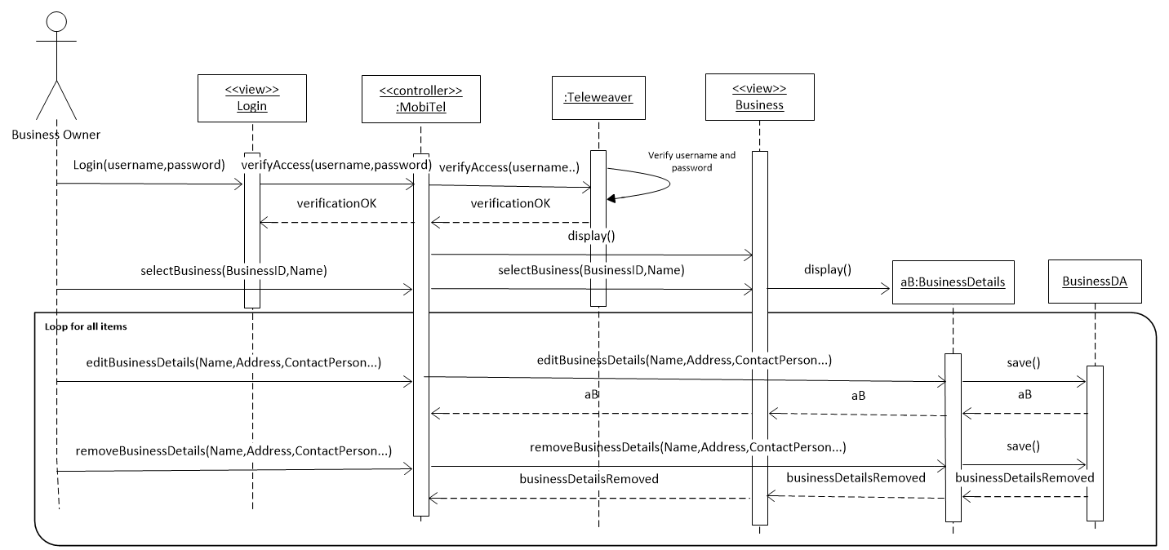

6.3.2 Multi-layer Sequence Diagram for Add Business Details

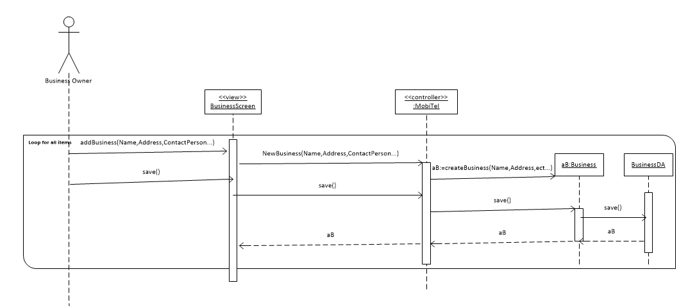

6.3.3 Multi-layer Sequence Diagram for Manage Accommodation Details

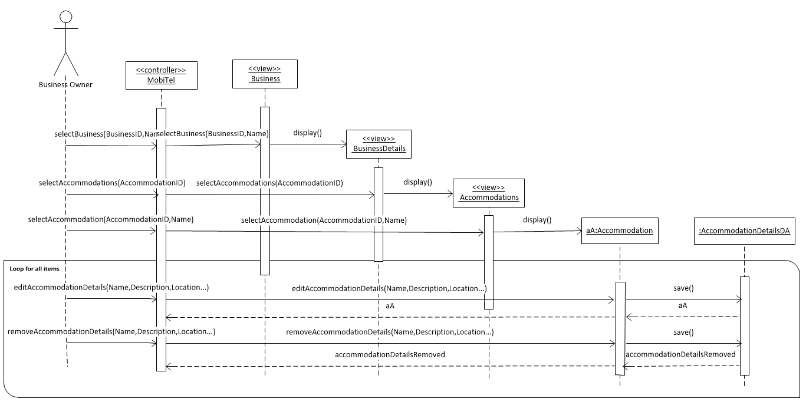

6.3.4 Multi-layer Sequence Diagram for Add Accommodation Details

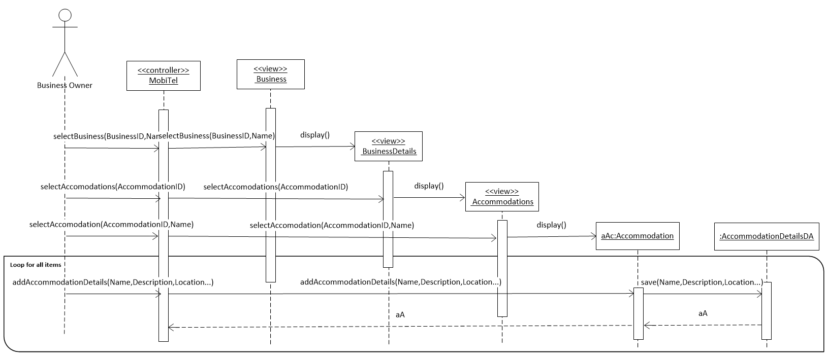

6.3.5 Multi-layer Sequence Diagram for Manage Room Details

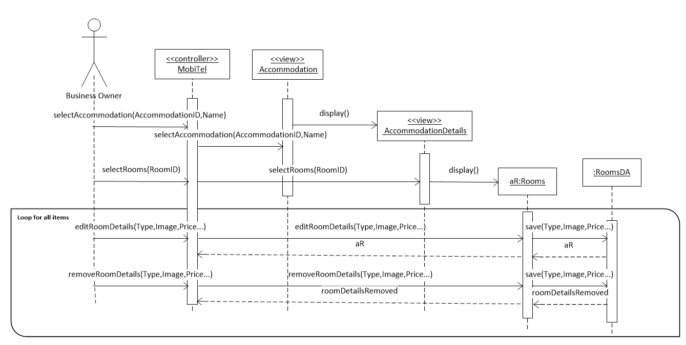

6.3.6 **Multi-layer Sequence Diagram for Add Room Details**

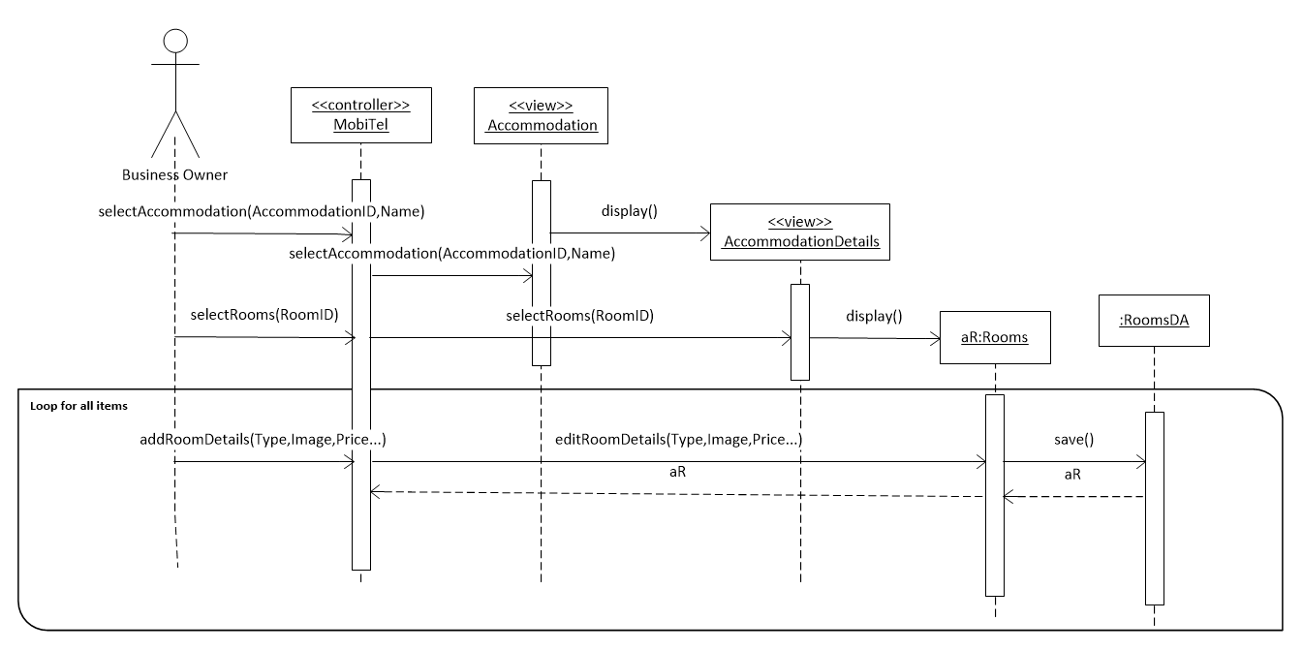

6.3.7 Publish Details

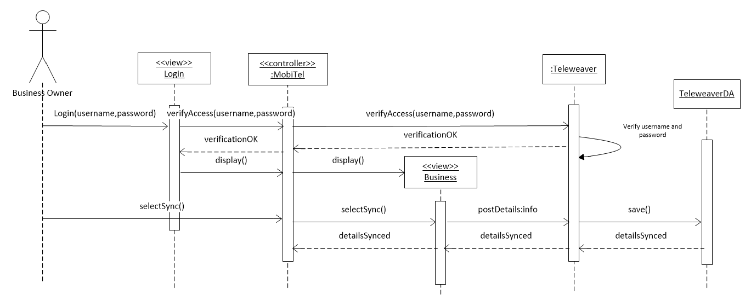

6.4. Design Class Diagram

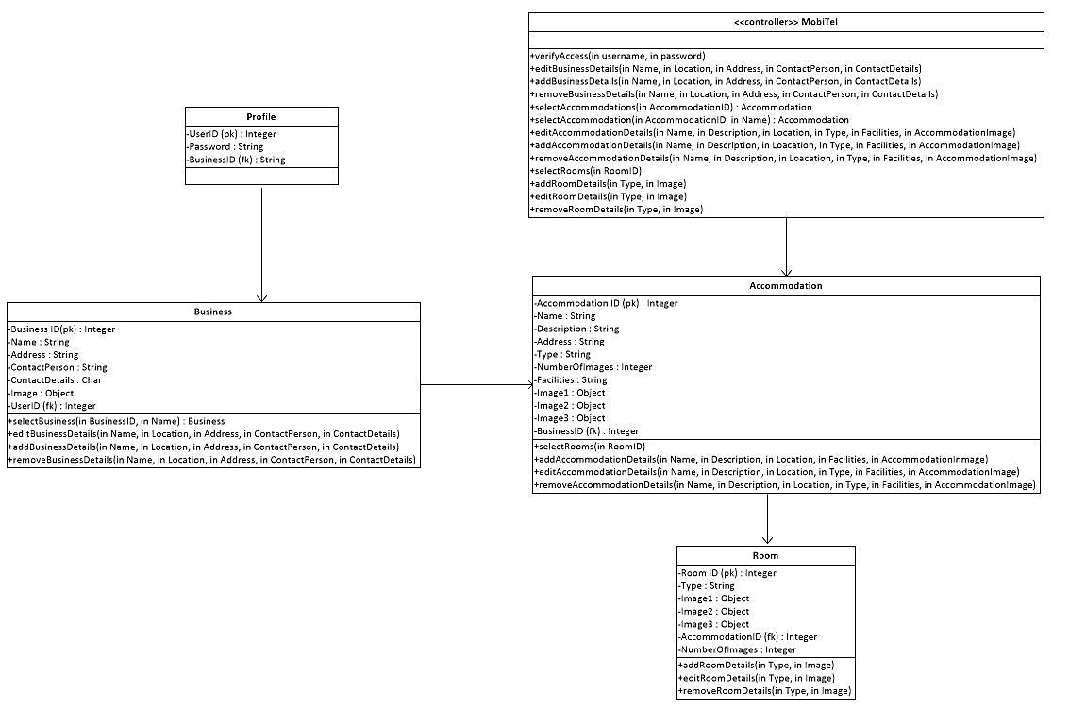

6.5. Package Diagram



1. Data Exchange Model

The MobiTel application is entirely dependent on Teleweaver as the external data provider. Without Teleweaver as a source of up-to-date content it would become less useful to the user as it would only be able to present a data backed up in a local memory. It would also be inefficient to pre-install a database of businesses into the device’s memory because this data set simply changes too often. The developers understand the cost implications of data transfer and to the best of our knowledge, the end users in the Dwesa community will have access to free Wi-Fi hotspot zones provided by Reed House Systems through the Siyakhula Living Lab project. However, users who are willing to use their own 2G/3G network and are prepared to incur the expense will still be able to transfer data.

7.1. REST client

The application will be using a REST (or Representational State Transfer) architecture. RESTful web services which accepts requests via the HTTP protocol are a widely spread standard adopted by numerous companies such as Google. Android itself does not provide any dedicated libraries to support implementations of RESTful APIs, however Android does provide a number of pre-implemented solutions that can be used extensively during the implementation, provided that the developers are aware of them. The internet can greatly assist with this regard.

1. Glossary

|  |  |
| --- | --- |
| **Terminology** | **Definition** |
| Activity Diagram | Shows the flow of the activities in the system. |
| Class | A group of objects that have an identical set of attributes and an individual set of behaviours. |
| Class Diagram | Describes the structure of the system by showing the classes, attributes, operations and relationships |
| Class Diagram | A diagram that shows the structure of the systems and has no behavioural content and shows the relationship between classes. |
| JAD | Joint Application Development. A process of attaining agreement on critical decisions about a systems requirements and design during an intensive workshop for all relevant stakeholders. |
| Sequence Diagram | Shows the interaction of the processes and how they operate with one another. |
| Stakeholder | A person who interacts with or is affected by the system is affected or affected by the system. |
| Use Case Diagram | This defines the interactions between an actor and the system. |
| Use Case Narrative | This describes the functions of the use cases present in the use case diagram use case diagram. |
| User | The user is a person who owns a B&B business and wishes to upload business details about their B&B. |

1. References

Satzinger, J., Jackson, R., and Burd, S. (2009). **Systems Analysis and Design in a Changing World (5e).** Course Technology.

Reed House Systems, JAD Session from 26/04/2013, Rhodes University, Grahamstown.

1. Appendix A
   1. JAD session minutes

**Date**: 26 July 2013

**Time:** 2.30 pm

**Present**: Luminus Solutions, Buyiswa Gora, Wendy Dwyili,

**Minutes:**

**Clients**

Clients are not well versed with smart phones as they have never possessed or had access to any.

There would be 2 user roles.

**The Business**

The business offers Bed and Breakfast (BnB) and catering facilities.

The definition of a homestay covers guests who come in and stay with the owners. Currently there are two bedrooms. One contains a double bed and a single bed and the other contains a double bed.

Wendy caters to out of town guests.

Guests become aware of the homestay by calling straight to the homestay or via Makana Tourism.

Customers who contact the Homestay directly can deposit money into their accounts directly or can pay cash.

Payments should ideally be made before arrival to guarantee booking.

Customer details that the Homestay captures includes:

* Customer Name and Surname
* Customer Address
* Phone Number
* ID Number

Information they would like to see displayed in the app include

* Prices
* Pictures
* Address
* Contact Details
* No pets allowed
* Blurb about the BnB (including the warmth of the house, a friendly place and lifetime relationships that are built).
* She requested if a logo can be created for her business using the KWAM e-Makana colours (blue and Red)

**KWAM e-Makana**

History behind Kwam is that it is a separate project that was headed by Nosipho premier that had the intention of being integrated into the Makana Tourism department as a whole.

Problems encountered with the current way of things is that a commission is paid to the Tourism Department for their administrative handling and that payments take a long time to be processed

During the festival period, customers who go through Makana Tourism are usually actors and artists participating in the Festival.

Customers usually come from Bisho.

Deposits will be made into Makana Tourism accounts.

In terms of advertising the homestay had a 3 year contract (2009-2011) with Fair trade and Tourism to advertise for them on a website. Advertising is now through word of mouth or through Makana.

1. Appendix B
   1. User Testing Briefing
      1. MobiTel Android Application User Test

**Background and Purpose of Application**

The developers have identified the need to build a mobile application that will enable and support SMME entrepreneurs promote their tourism offerings in the Dwesa community though Teleweaver. The application will allow members of the Dwesa community who have guest accommodation services (Bed & Breakfast, Homestay and Self-catering accommodation) to: Enter and modify details about their accommodation service(s); and upload pictures of their offering onto Teleweaver.

**Purpose of the user testing**

Your input is invaluable in ensuring that the application meets your expectations and needs as the user, and is usable.

**Process**

* You will be given index cards with scenarios instructing you to perform certain tasks on the Android application.
* At the start of each task, you will read aloud the task narrative from the index card and begin the task.
* You are encouraged to use your fingers to indicate where you are clicking and to also say this aloud.
* As the participant you will be evaluating the application, rather than the facilitator evaluating you, so feel free to act at your discretion.
* Please remember that participation is voluntary and can cease at any time.
* The session will be observed by three observers and its results are confidential.
* Do you have any questions?

*********************Thank you for your participation!*************************

* 1. User Testing
     1. Scenarios

The users were presented with the following scenarios for testing:

**Scenario 1**

You are the owner of Wendy’s, an accommodation business in Joza, Grahamstown. You are expanding your operations and wish to add a new business onto the system. This business is called “Buyiswa’s”, it is also an accommodation business; contact number is 0745742897; address is 17 Ncame Street, Joza, Grahamstown, 6139.

**Scenario 2**

You have decided to also expand “Wendy’s” operations. You have renovated and expanded Wendy’s Homestay. The homestay now has 5 bedrooms and 3 bathrooms and you wish to edit/change this information on the system using the mobile application.

**Scenario 3**

Six months after operations, Buyiswa’s – your new business, experiences some financial troubles and you decide to close it down. You now wish to remove this business from the system using the mobile application.

Observations

**Client Testing**

**Date: 9 September 2013**

**Facilitator: Sinako Cetyiwe**

**Scenario 1**

* The user was initially uncomfortable with using the device and was a little hesitant to touch the device. She was unfamiliar with the android keyboard and needed a little prompting as to where certain items where for example the delete button.
* The user was very quick to catch on and familiarize themselves with the environment once she knew where stuff was.
* The user confused what Contact Number meant and first asked if a contact number or pin number was required.
* For testing purposes the user was able to identify the save buttons even though the icons were not visible.
* The user did not follow the format of the address bar.

**Scenario 2**

* The user was unsure of where to make changes for Wendy’s Homestay and she was a little hesitant to click on the Wendy’s Homestay.
* Once in the Accommodation details there was initially a little hesitation with identifying where to click.
* In changing the 3 bedrooms, she clicked in the box and then clicked the cancel button.

**Scenario 3**

* In order to remove the accommodation the user initially clicked on the edit button in order to remove the BnB.
* She then clicked the Cancel button to remove the BnB.

**Comments from the user**

* She is happy with the colour and it suits her well.
* She would prefer if the app was available in IsiXhosa.
* She was unable to see the dropdown menu (platform version problem)
* She would prefer if the address lines were all merged into 1.

**Representative User Testing**

**Date: 10 September 2013**

**Facilitator: Lwando Sobekwa**

**User 1**

**Scenario 1**

* The user was very hesitant to make contact with the phone and when prompted to pursue the first scenario she was very uncomfortable.
* She then later revealed that she could not read.
* Through further prompting by Lwando who was facilitating the session she was able to identify the Add icon to then add a business.
* The user was unable to recognise or recall the meaning of the logout or sync button.
* The user made several guesses and attempted to press all buttons.

**Scenario 2**

* The user kept mistaking the “Home” icon for the “Homestay” accommodation.
* The user expressed frustration and ended the session as she was unable to continue due to time constraints.

**Comments from the user**

* The user expressed their concern about the usability of the application for other users who can’t read or write.

**User 2**

**Scenario 1**

* The user was firstly a little hesitant to engage with the device and also to use the keyboard.
* The user understood the scenario but was unable to enter the data as she was uncomfortable using the touch screen keyboard.
* The user then chose to explain verbally how they would execute the scenario.

**Scenario 2**

* For this scenario the user took a while to identify that they were able to lick on the Wendy’s Homestay Button. She kept clicking on the Home button.
* In changing the number of bathrooms the user struggled to make use of the drop down menu and kept using the cancel button as a means to remove.
* The user confused the cancel button to mean the remove button.
* The user again was unable to further make changes using the app and chose to explain verbally how they would execute the scenario.

**Comments from the user**

The user maintained that they would not like to engage with a touch screen as it is hard to adjust to.

**Possible solutions as informed by observations and user comments:**

* Have the application available in IsiXhosa
* Provide a thorough user manual document
* Provide help functionality within the application
* All icons should have labels

**User 3**

**Scenario 1**

* The user was calm and eager to engage with the device and the keyboard.
* The user understood the scenario but needed to be prompted to check for an icon to add a business.
* The user did not understand the isiXhosa translations on the mobile application.
* The user did not add a photo for the business.

**Scenario 2**

* The user understood the scenario but did not use the edit icon.
* The user understood how to upload a photo.

**Comments from the user**

The user found the colour and pictures used on the mobile application to be appealing.

**Possible solutions as informed by observations and user comments:**

* Provide a thorough user manual document.
* The icons and labels need to be bigger to grab the user’s attention.

**User 4**

**Scenario 1**

* The user immediately knew to press the ‘Add’ icon.
* The user entered a wrong cellphone number and immediately corrected their mistake when a hint text was shown.

**Scenario 2**

* The user understood the scenario and knew to select a business in order to edit it.
* The user struggled to locate accommodation details and disregarded the Accommodation Button.
* The user then chose to explain that they were looking for an accommodation icon to select.

**Comments from the user**

* The user would like to have more lines in the address field.
* The user related a dialog with Yes, No and Cancel with a desktop and suggested that only two options (Yes, No) with a mobile application.

**Possible solutions as informed by observations and user comments:**

* Most of the issues encountered by the user pertained to the use of the device as opposed to the use of the mobile application.
* The dialog boxes can be changed to have only two options (Yes and No) as opposed to three options (Yes, No, Cancel).